Contents

**Types of Statistics** 2

**Central Tendency** 4

1. effect of outliers in mean 4

2. Median 4

3. Mode 4

**What is Probability and Vocabulary of Probability** 8

**The Basic Counting Principle** 10

**Independent or Dependent?** 10

**Probability: Types of Events** 12

**Permutations and Combinations** 13

**1. Permutations with Repetition** 14

**2. Permutations without Repetition** 14

**Probability Density Function** 26

**Different types of Variables** 28

**Variables Measurement Scale** 28

**Cumulative distribution function vs Probability Density Function** 29

**Probability Density Function** 30

**Sample Techniques** 39

# **Types of Statistics**

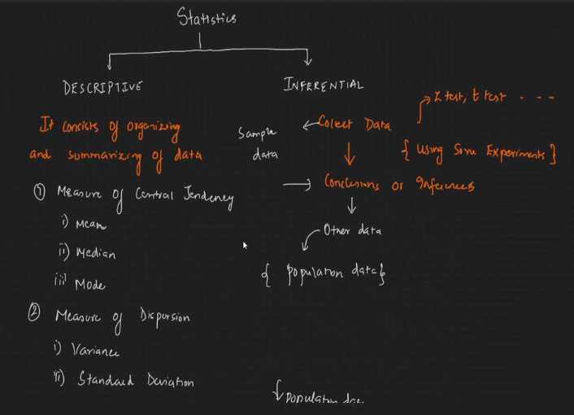

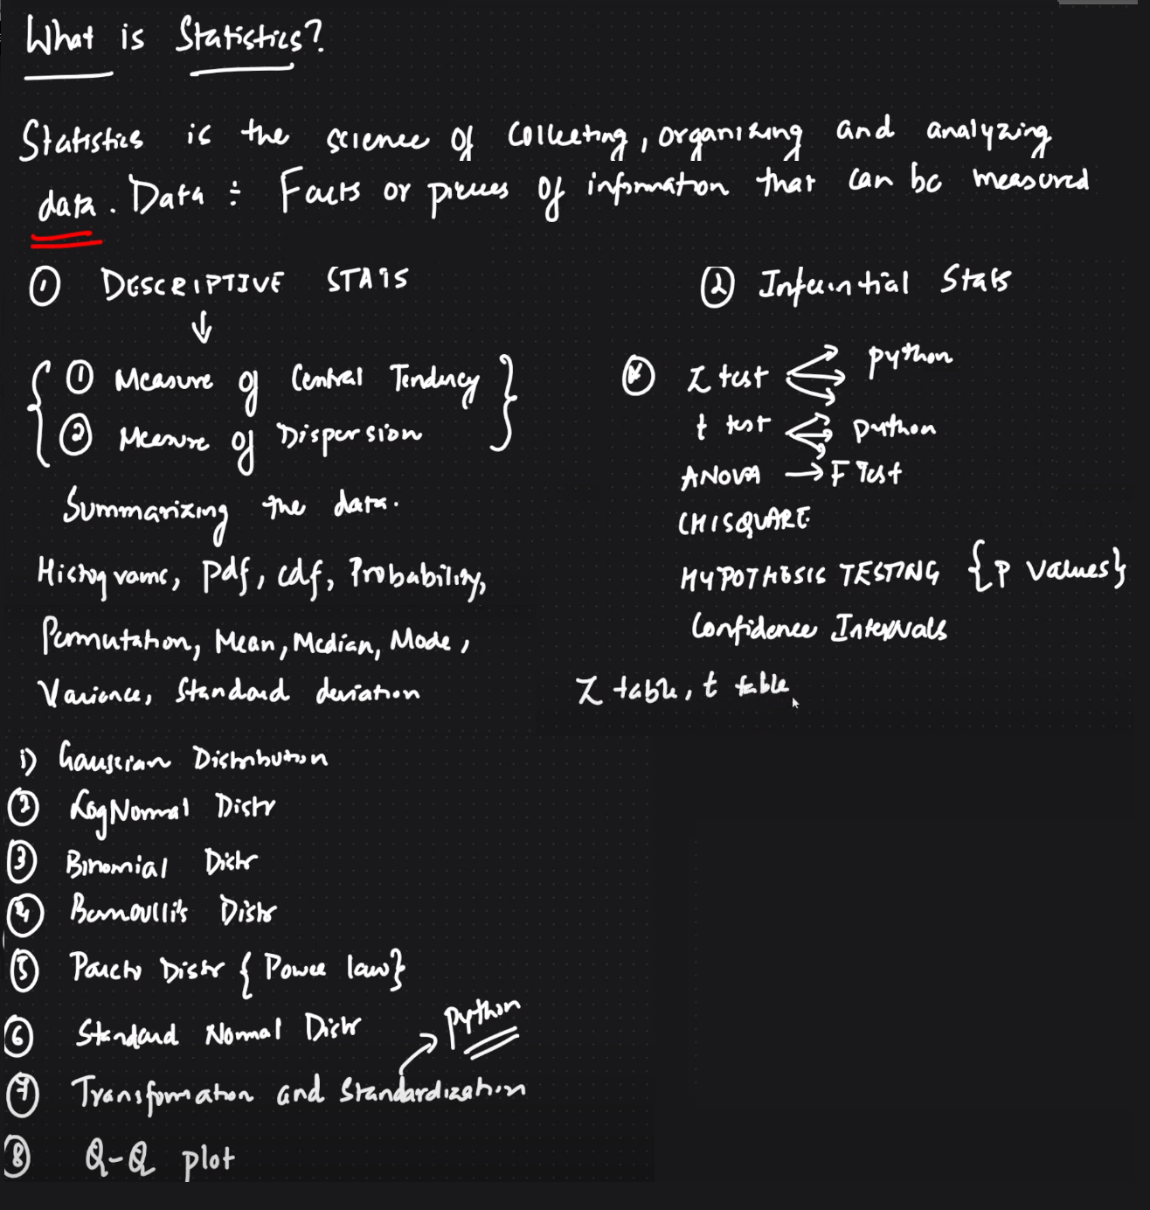

**Arithmetic mean for Population & Sample**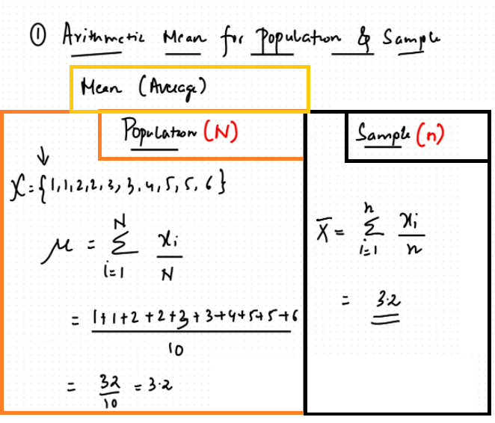

# **Central Tendency**

### effect of outliers in mean

### Median

### Mode

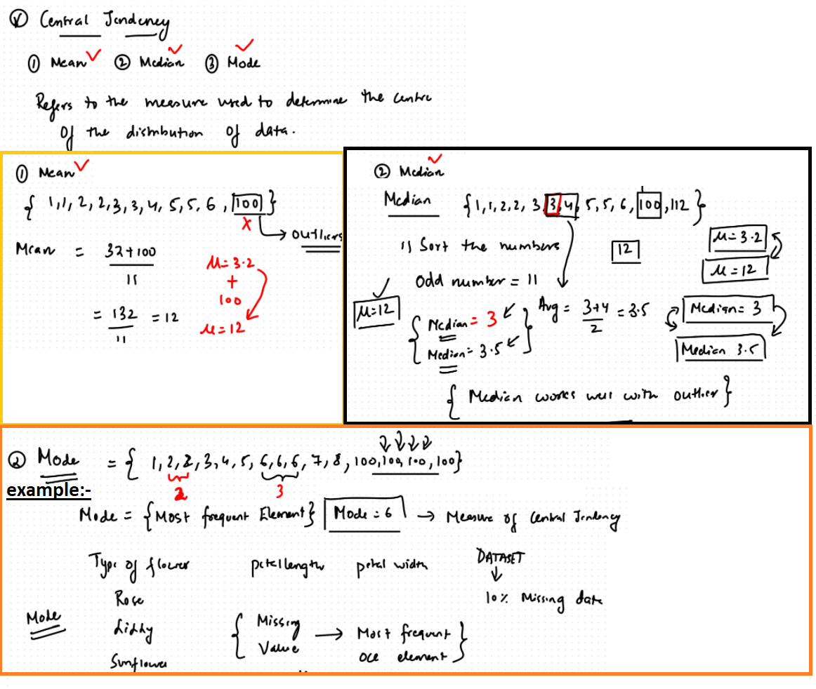

**Measures of Dispersion**

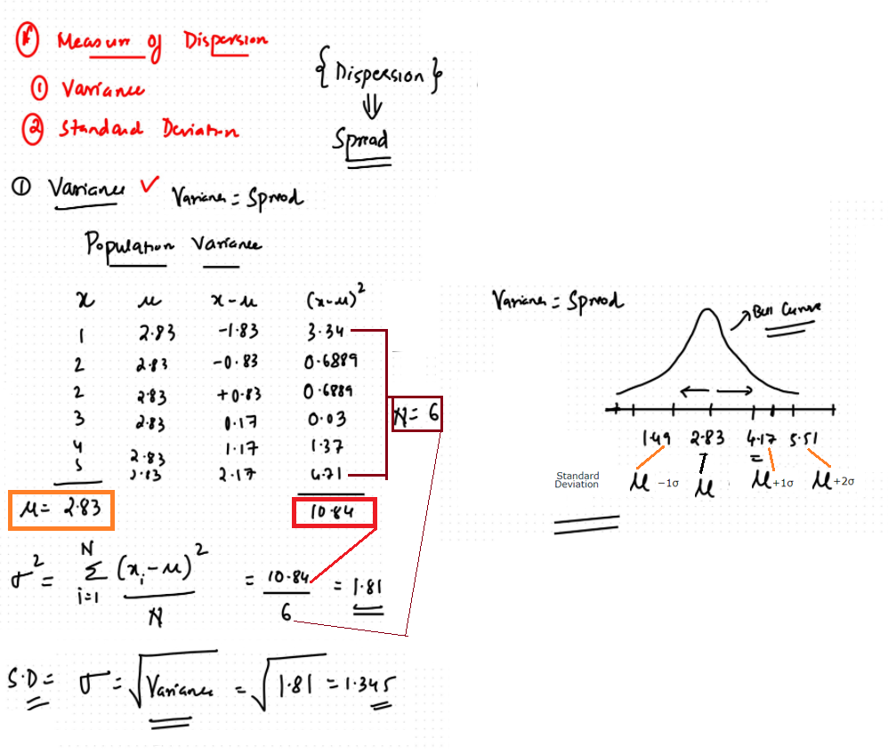

**Variance**

**Standard Deviation**

**Importance of STD and Var**

**Percentile**

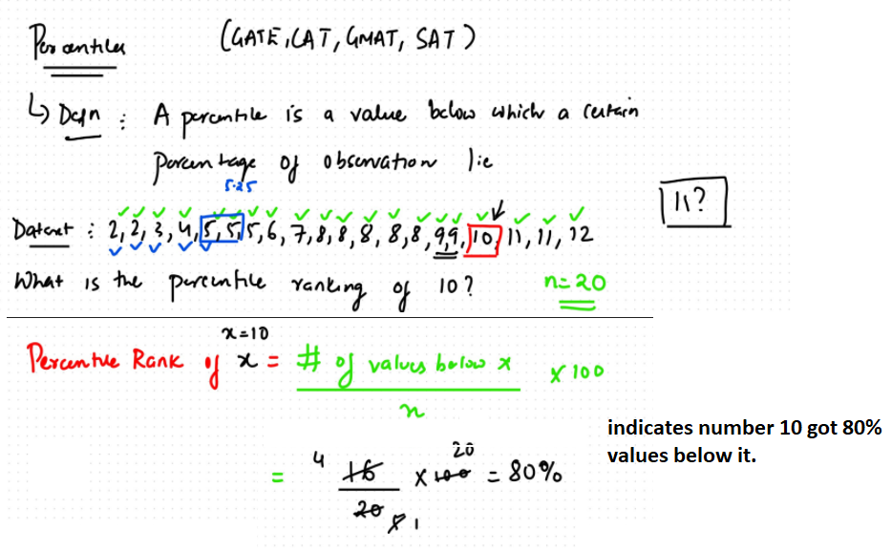

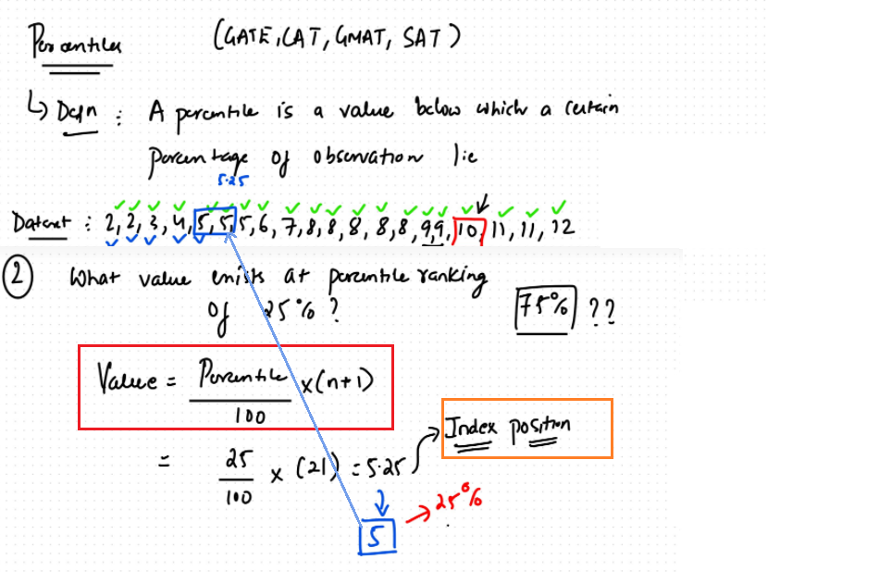

**Five number summary(Box plot, outliers, Q1 first quartile & Q3 Third Quartile)**

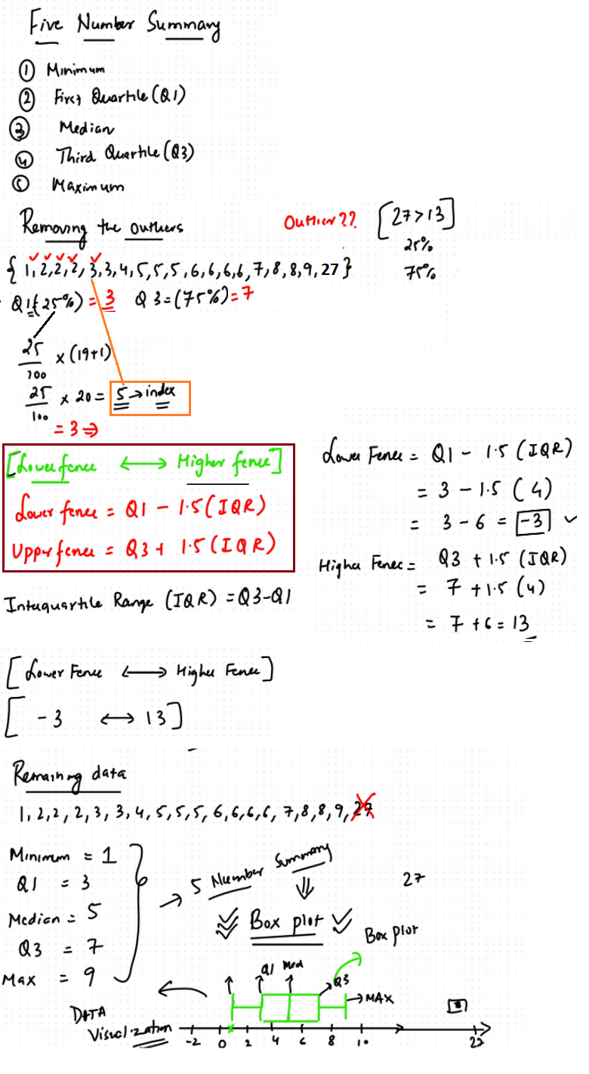

# **What is Probability and Vocabulary of Probability**

**Probability:-**How likely something is to happen.

Many events can't be predicted with total certainty. The best we can say is how likely they are to happen, using the idea of probability.

* ***When a coin is tossed, there are two possible outcomes* heads (H) or tails (T)**

We say that the probability of the coin landing **H is ½** And the probability of the coin landing **T is ½**

* ***When a single die is thrown, there are six possible outcomes: 1, 2, 3, 4, 5, 6.***

*The probability of any one of them is* ***1/6***

**In general:**

|  |
| --- |
| **Probability of an event happening = Number of ways it can happen/Total number of outcomes** |

**There are 5 marbles in a bag: 4 are blue, and 1 is red. What is the probability that a blue marble gets picked?**

***Number of ways it can happen:*** *4 (there are 4 blues)* ***Total number of outcomes****: 5 (there are 5 marbles in total)*

*So the probability* ***= 4/5 = 0.8***

**Probability line:**

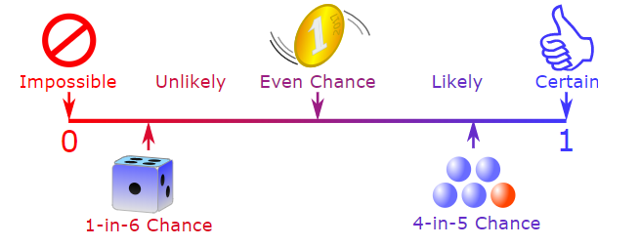

The probability of an event occurring is somewhere between impossible and certain. We can use numbers to show the probability of something happening:

• Impossible is **zero** • Certain is **one**

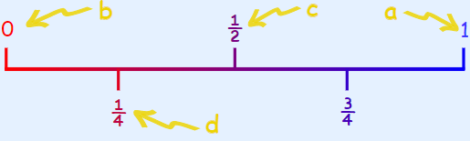

a) The sun will rise tomorrow(**Prob 1)** b) I will not have to learn mathematics at school **(Prob 0)**

c) If I flip a coin it will land heads up(**Prob ½**) d) Choosing a red ball from a bag with 1 red ball and 3 green balls(**prob ¼**)

**Between 0 and 1:** The probability of an event will not be less than 0.This is because **0 is impossible (sure that something will not happen)**.

The probability of an event will not be more than 1.This is because **1 is certain that something will happen.**

**Probability does not tell us exactly what will happen, it is just a guide:-**

Example: **toss a coin 100 times**, how many Heads will come up?

Probability says that heads have a ½ chance, so we can expect 50 Heads.But when we **actually** try it we might get **48 heads, or 55 heads** ... or anything really, but in most cases it will be a number **near 50.**

**Vocabulary of Probability:-**

1. **Experiment**: a repeatable procedure with a set of possible results.

Example: **Throwing dice,** We can throw the dice again and again, so it is repeatable.

The set of possible results from any single throw is **{1, 2, 3, 4, 5, 6}**

1. **Outcome:** A possible result of an experiment.

Example: Getting a "6" when dice is thrown

1. **Sample Space**: all the possible outcomes of an experiment.

Example: choosing a **card** from a **deck,**There are 52 cards in a deck (not including Jokers) So the Sample Space is all 52 possible cards: {Ace of Hearts, 2 of Hearts, etc... }

The **Sample Space** is made up of **Sample Points**

1. **Sample Point**: just one of the possible outcomes,ex:- **Throwing dice**,There are **6** different **sample points{1, 2, 3, 4, 5, 6}** in the sample space.
2. **Event**: one or more outcomes of an experiment.ex:- An event can be just one outcome:

**Getting a Tail** when **tossing a coin or** Rolling a "5" when **dice is thrown**.

An **event** can include more than one outcome:Choosing a **"King"** from a **deck** of cards (any of the **4 Kings**).

Rolling an "**even number**" (2, 4 or 6) when dice is thrown.

Here is the example using all the above **probability vocabulary** :-

**Example**: Alex wants to see how many times a "**double**" comes up when throwing **2 dice**.

The **Sample Space** is all possible Outcomes (**36 Sample Points**):

**Sample Space** ={1,1} {1,2} {1,3} {1,4} ... {6,3} {6,4} {6,5} {6,6} 🡪 Total 36 Sample Points

The **Event** Alex is looking for is a "**double**", where both dice have the **same number**. It is made up of these **6 Sample Points**:

{1,1} {2,2} {3,3} {4,4} {5,5} and {6,6}

These are Alex's Results:

Experiment Is it a Double?

{3,4} No

{5,1} No

{2,2} Yes

... ...

**After 100 Experiments**, Alex has **19 "double" Events(after trying out 100 times)**

**The Basic Counting Principle** When there are m ways to do one thing, and n ways to do another,then there are **m×n ways of doing both**.

**Example**: There are **6 flavours of ice-cream**, and 3 different cones. That means **6×3=18 different** single-scoop ice-creams you could order.

**Example**: You are buying a **new car**.

There are 2 body styles: sedan or hatchback

There are 5 colours available: **BLACK,RED,GREEN,BLUE,ORANGE**

There are **3 models** GL(standard model),SS (sports model with bigger engine),SL (luxury model with leather seats)

How many total choices?

**Sedan**={GLBLACK,SSBLACK,SLBLACK}{GLRED,SSRED,SSLRED}{GLGREEN,SSGREEN,SLGREEN}{GLBLU,SSBLUE,SLBLUE}{GLORANGE,SSORANGE,SLORANGE}

**Hatchback**={GLBLACK,SSBLACK,SLBLACK}{GLRED,SSRED,SSLRED}{GLGREEN,SSGREEN,SLGREEN}{GLBLU,SSBLUE,SLBLUE}{GLORANGE,SSORANGE,SLORANGE}

**Total Choices** = 2 × 5 × 3 = **30**

**In the above all the choices are independent of each other.**

### **Independent or Dependent?**

If one choice affects another choice (i.e. depends on another choice), **then a simple multiplication is not right**.

Example: You are buying a new car.the salesman says "**You can't choose black for the hatchback**" ... well then things change!

There are 2 **body styles**: sedan or hatchback

There are 5 **colors** available: BLACK,RED,GREEN,BLUE,ORANGE

There are 3 models:GL (standard model),SS (sports model with bigger engine),SL (luxury model with leather seats)

How many total choices?

**Sedan**={GLBLACK,SSBLACK,SLBLACK}{GLRED,SSRED,SSLRED}{GLGREEN,SSGREEN,SLGREEN}{GLBLU,SSBLUE,SLBLUE}{GLORANGE,SSORANGE,SLORANGE}

**Hatchback**={GLGREEN,SSGREEN,SLGREEN}{GLBLU,SSBLUE,SLBLUE}{GLORANGE,SSORANGE,SLORANGE}

Total Choices = **5 × 3+4 x 3** = 27 choices ( you can also count the above)

**Relative Frequency:-**

How often something happens divided by all outcomes.

**Example 01**: Your team has won 9 games from a total of 12 games played in cricket:

the **Frequency** of **winning** is 9,the **Relative** **Frequency** of winning is 9/12 = **75%**

**All the Relative Frequencies add up to 1.**

Example 02**:- 92 people** were asked how they got to work:

35 used a car

42 took public transport

8 rode a bicycle

7 walked

The Relative Frequencies (to 2 decimal places) are:

Car: 35/92 = 0.38,Public Transport: 42/92 = 0.46,Bicycle: 8/92 = 0.09,Walking: 7/92 = 0.08

**0.38+0.46+0.09+0.08 = 1**

**Probability: Complement:-**

Complement of an Event: **All** outcomes that are **NOT** the event.

The probability of an event is shown using **"P": P(A) means "Probability of Event A"**

The complement is shown by a little mark after the letter such as **A' (or sometimes Ac or A)**:

**P(A') means** "Probability of the complement of Event A"

The two probabilities always **add to 1**:- **P(A) + P(A')** = 1

**Example 01**: Rolling a "5" or "6"

probability complement

**Event A is {5, 6}**

Number of ways it can happen: 2

Total number of outcomes: 6

P(A) = 2/6 = 1/3

The **Complement of Event A** is {1, 2, 3, 4}

Number of ways it can happen: 4

Total number of outcomes: 6

P(A') = 4/6 = **2/3**

Let us add them:

**P(A) + P(A') = 1/3 + 2/3 = 3/3 = 1**

Event A plus all outcomes that are not Event A make up all possible outcomes and they sum up to one(1)

**Why is the Complement Useful?** :- It is sometimes easier to work out the complement first.

**Example 02**. Throw two dice. What is the probability the two scores are different?

Different scores are like getting a 2 and 3, or a 6 and 1. It is a long list:

**A = { (1,2), (1,3), (1,4), (1,5), (1,6),(2,1), (2,3), (2,4), (1,5), (1,6),(3,1), (3,2), ... etc ! }**

But the complement (which is when the two scores are the same) is only 6 outcomes:

**A' = { (1,1), (2,2), (3,3), (4,4), (5,5), (6,6) }**

And its probability is: **P(A') = 6/36 = 1/6**

Knowing that P(A) and P(A') together make 1, we can calculate:

P(A) = 1 − P(A') = 1 − 1/6 = 5/6

It is always easier to work out **P(A') first**, then calculate **P(A) = 1 − P(A')**

# **Probability: Types of Events**

**Events**: When we say "Event" we mean one (or more) outcomes.

**Example** Events: Getting a Tail when tossing a coin is an event. Rolling a "5" is an event when Dice is thrown.

An event can include **several outcomes**:Choosing a "King" from a deck of cards (any of the 4 Kings) is also an event

Rolling an "even number" (2, 4 or 6) is an event

**Events can be:**

* Independent (each event is not affected by other events),
* Dependent (also called "Conditional", where an event is affected by other events)
* Mutually Exclusive (events can't happen at the same time)

**Independent Events: -**

Events can be "**Independent**", meaning each event is not affected by any other events.

This is an important idea! A coin does not "know" that it came up heads before ... each toss of a coin is a **perfect isolated thing**.

Example: You toss a coin three times and it comes up "Heads" each time ... what is the chance that the next toss will also be a "Head"?

***The chance is simply 1/2, or 50%, just like ANY OTHER toss of the coin.***

***Dependent Events:-***But some events can be "dependent" ... which means they can be affected by ***previous events***.

Example: Drawing 2 Cards from a Deck, After taking one card from the deck there are less cards available, so the probabilities change!

Let's look at the chances of getting a King.For the 1st card the chance of drawing a King is 4 out of 52

But for the 2nd card:If the 1st card was a King, then the 2nd card is less likely to be a King, as only 3 of the 51 cards left are Kings.

If the 1st card was not a King, then the 2nd card is slightly more likely to be a King, as 4 of the 51 cards left are King.

This is because we are removing cards from the deck.

***Replacement***: When we put each card back after drawing it the ***chances don't change***, as the events are **independent**.

**Without Replacement:** The chances will change, and the **events are dependent**.

When we have **Dependent Events** it helps to make a "**Tree Diagram**"

Example: Soccer Game,You are off to soccer, and **love being the Goalkeeper**, but that depends who is the Coach today:

**with Coach Sam** your probability of being Goalkeeper is 0.5

**with Coach Alex** your probability of being Goalkeeper is 0.3

Sam is Coach more often ... **about 6 of every 10 games (a probability of 0.6).**

Start with the Coaches. We **know 0.6 for Sam**, so it must be **0.4 for Alex** (the probabilities must add to 1):

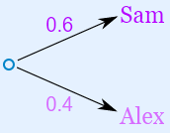

Then fill out the branches for Sam (0.5 Yes and 0.5 No), and then for Alex (0.3 Yes and 0.7 No):

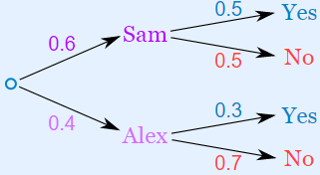

**Mutually Exclusive** means we can't get both events at the same time. It is either one or the other, but not both

Examples:

* Turning left or right are Mutually Exclusive (you can't do both at the same time)
* Heads and Tails are Mutually Exclusive
* Kings and Aces are Mutually Exclusive

What isn't Mutually Exclusive

Kings and Hearts are not Mutually Exclusive, because we can have a King of Hearts!

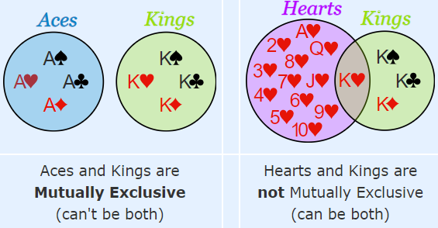

# **Permutations and Combinations**

**Combination** :-When the order does not matter, it is a Combination.

**Permutation :-**When the order does matter it is a Permutation. A Permutation is an ordered Combination. To help you to remember, think "**Permutation ... Position**"

***Permutations***:-There are basically **two types** of permutation:

* Repetition is Allowed: such as the lock above(3 number locker). It could be "333".
* No Repetition: for example, the first **three people in a running race**. You can't be first and second.

**1. Permutations with Repetition:-**These are the easiest to calculate.

When a thing has n different types ... we have n choices each time!

For example: choosing 3 of those things, the permutations are:

**n × n × n**

**(n multiplied 3 times)**

More generally: choosing r of something that has n different types, the permutations are:

n × n × ... (r times)

(In other words, there are n possibilities for the first choice, THEN there are n possibilities for the second choice, and so on, multplying each time.)

Which is easier to write down using an exponent of r:

**n × n × ... (r times) = nr**

Example: in the lock , there are 10 numbers to choose from (0,1,2,3,4,5,6,7,8,9) and we choose 3 of them:

10 × 10 × ... (3 times) = 10(pow 3) = 1,000 permutations

So, the formula is: **nr**

where **n is the number of things** to choose from, and we choose **r** of them, repetition is allowed,

and order matters.

### **2. Permutations without Repetition**

In this case, we **have to reduce the number** of available choices each time.

**Example 01:** what order could 16 pool balls be in?

After choosing, say, number "14" we can't choose it again.So, our first choice has 16 possibilities, and our next choice has 15 possibilities, then 14, 13, 12, 11, ... etc. And the total permutations are:

**16 × 15 × 14 × 13 × ... = 20,922,789,888,000**

But maybe we don't want to choose them all, **just 3 of them**, and that is then:**16 × 15 × 14 = 3,360**

In other words, there are 3,360 different ways that 3 pool balls could be arranged out of 16 balls.

Without repetition our choices get reduced each time.

**Ex 02:-** lets assume you have 3 balls numbered s 1,2,3 then person can draw

**{1,2,3}{1,3,2}**

**{2,3,1}{2,1,3}**

**{3,1,2}{3,2,1}**

the formula is:3x2x1=**6**

The factorial function (**symbol: !)** just means to multiply a series of descending natural numbers. Examples:

4! = 4 × 3 × 2 × 1 = 24

7! = 7 × 6 × 5 × 4 × 3 × 2 × 1 = 5,040

1! = 1

***Note: it is generally agreed that 0! = 1***.

The formula is written: **n!/(n − r)!**

where **n is the number of things to choose** from, and we choose r of them, **no repetitions**, order matters.

From our **example01**:-Example Our "**order of 3 out of 16 pool balls** example" is:

16!/ (16-3)!= 16!/13! =3,360

(which is just the same as: 16 × 15 × 14 = 3,360)

From our **example02**:-Example Our "**Drawing 3 numbers balls”** is:

Here **r** signifies how many balls you draw(here we are drawing 3 balls)

3!/ (3-3)!= 3!/0! =6/1=6

(**which is just the same as: 3× 2× 1 = 6**)

**Notation:-**

Instead of writing the whole formula, people use different notations such as these:

***permutation notation P(n,r***) = **nPr** = n!/(n-r)!

**Combinations**

There are also two types of combinations (remember the **order does not matter now**):

* **Repetition is Allowed**: such as coins in your pocket (5rs,5rs,5rs,10rs,10rs)
* **No Repetition**:lottery numbers (2,14,15,27,30,33) (usually winning lottery numbers don’t get repeated)

**Combinations without Repetition:-**

Lets assume there is one lottery company which draws out 6 winning digits. The numbers are drawn one at a time, and if we have the lucky numbers (no matter what order) we win!

The easiest way to explain it is to:assume that the **order does matter (ie permutations)**,

then alter it so the order does not matter.

Going back to our example02, let's say we just want to know which 3 pool balls are chosen, not the order.

**We already know that 3 out of 3 gave us 6 permutations.**

|  |  |
| --- | --- |
| Order does matter **Permutation** | Order does not matter **Combination** |
| 1 2 3 | 1 2 3 |
| 1 3 2 |
| 2 1 3 |
| 2 3 1 |
| 3 1 2 |
| 3 2 1 |

But many of those are the same to us now, **because we don't care what order!**

So we adjust our **permutations formula to reduce** it by how many ways the objects could be in order (because **we aren't interested in their order any more**):

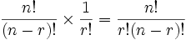

That formula is so important it is often just written in big parentheses like this:

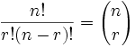

**Notation:-**As well as the "big parentheses", people also use these notations: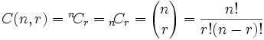

where n is the number of things to choose from, and we choose r of them, **no repetition**, **order doesn't matter.**

It is often called "**n choose r**" And is also known as the **Binomial Coefficient.**

**For example 02:-**

**n = 3( 3 balls marked 1,2,3) r=3 (Drawing 3 ball)**

**3!/(3-3)! X 1/3!= (6/1)*(1/6)=1** [{1,2,3} is the only combination]

**For example 01:-** So, our pool ball example (now without order) is:

**n=16 balls r=3 balls (drawing 3 balls)**

= 16!/3!(16−3)! = 16!/3! × 13!= 16×15×14/3×2×1 = **3360/6 = 560**

**Example 03:-**

If there are 4 balls and 3 balls are drawn out of it then what is the combination: -

**PERMUTATION IS:-**

{1,2,3}{1,2,4}{1,3,4}{1,4,2}{1,4,3}{1,3,2}

{2,1,3}{2,3,1}{2,4,1}{2,4,3}{2,3,4}{2,1,4}

{3,1,2}{3,1,4}{3,2,1}{3,2,4}{3,4,1}{3,4,2}

{4,1,2}{4,1,3}{4,2,1}{4,2,3}{4,3,1}{4,3,2}

**Total Permutation is =**24 (n=4 r=3 permutation=n!/(n-r)! permutation= 4!/(4-3)!= 24)

**COMBINATION IS:**

{1,2,3}{1,2,4}{1,3,4}{2,3,4}

**Total Permutation is =**4 (n=4 r=3 permutation=n!/r!(n-r)! Combination= 4!/3!(4-3)!= 4)

**Combinations with Repetition (this is very less used don’t worry too much about this)**

Let us say there are five flavors of icecream**: banana, chocolate, lemon, strawberry and vanilla**.

We can have three scoops. How many variations will there be? **letters for the flavors: {b, c, l, s, v}**

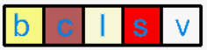

Think about the ice cream being in boxes, we could say "move past the first box**, then take 3 scoops, then move along 3 more boxes to the end**" and we will have 3 scoops of chocolate!

So it is like we are ordering a robot to get our ice cream, but it doesn't change anything, we still get what we want.

We can write this down as 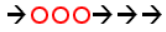 (arrow means move, circle means scoop).

OK, so instead of worrying about different flavours,we have a simpler question: "**how many different ways can we arrange arrows and circles?"**

Notice that there are always 3 circles (3 scoops of ice cream) and 4 arrows (**we need to move 4 times to go from the 1st to 5th container**).So (being general here) there are r + (n−1) positions, and we want to choose r of them to have circles.

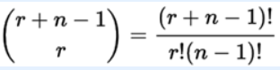

where n is the number of things to choose from,and we choose r of them **repetition allowed**,

**order does not matter.**

**There are 35 ways of having 3 scoops from five flavors of icecream.**

**False Positives and False Negatives**

When you have a test that can say **"Yes" or "No" (such as a medical test)**, you have to think:

It could be **wrong** when it says "**Yes**" OR It could be **wrong** when it says "**No**".Wrong?

Or you didn't do it when you really did.

They each have a special name: **"False Positive" and "False Negative":**

|  |  |  |
| --- | --- | --- |
|  | They say you **did** | They say you **didn't** |
| You really did | **They are right!** | **"False Negative"** |
| You really didn't | **"False Positive"** | **They are right!** |

**Here are some examples of "false positives" and "false negatives**":

* Airport Security: a "**false positive**" is when ordinary items such as keys or coins get mistaken for weapons (machine goes "beep").
* Quality Control: a "**false positive**" is when a good quality item gets rejected, and a "**false negative**" is when a poor quality item gets accepted. (A "positive" result means there IS a defect.)
* Antivirus software: a "**false positive**" is when a normal file is thought to be a virus
* Medical screening: Medical tests given to a large group can give many **false positives** (saying you have a disease when you don't), and then ask you to get more accurate tests.

Here are some examples of "false positives" and "false negatives":

* Airport Security: a "false positive" is when ordinary items such as keys or coins get mistaken for weapons (machine goes "beep")
* Quality Control: a "false positive" is when a good quality item gets rejected, and a "false negative" is when a poor quality item gets accepted. (A "positive" result means there IS a defect.)
* Antivirus software: a "false positive" is when a normal file is thought to be a virus
* Medical screening: low-cost tests given to a large group can give many false positives (saying you have a disease when you don't), and then ask you to get more accurate tests.

**Example: Allergy or Not?**

Jhon says he is itchy. There is a test for Allergy , but this test is **not always right**:

For people that really do **have the allergy**, the test says **"Yes" 80% of the time**

For people that **do not have the allergy**, the test says **"Yes" 10% of the time ("false positive")**

|  |  |  |
| --- | --- | --- |
|  | Test says "Yes" | Test says "No" |
| Have allergy | **80%** | **20% "False Negative"** |
| Don't have it | **10% "False Positive"** | **90%** |

False Positive something like even if you **don’t have CANCER** doctor says **you have CANCER**.

False Negative something like Even **if you have CANCER** doctor says you **don’t have CANCER**(False Negative are bad compared to False positive)

**Question**: If **1% of the population** have the allergy, and Jhon **test says "Yes"**, what are the chances that **Jhon really has the allergy**?

Do you think 75%? Or maybe 50%?

There are three different ways to solve this:

* **"Imagine a 1000",**
* **"Tree Diagrams" or**
* **"Bayes' Theorem",**

1. **"Imagine a 1000":-**

Try Imagining A Thousand People When trying to understand questions like this, just imagine a large group (say 1000) and play with the numbers:

* Of 1000 people, only 10 really have the allergy (1% of 1000 is 10)
* The test is **80% right** for people who **have** the allergy, so **it will get 8 of those 10 right**.
* **But 990 do not have the allergy**, and the test will say **"Yes" to 10% of them**,

which **is 99 people it says "Yes" to wrongly** (false positive)

* So out of **1000 people** the test says **"Yes" to (8+99) = 107 people**

|  |  |  |  |
| --- | --- | --- | --- |
|  | **1% have it** | **Test says "Yes"** | **Test says "No"** |
| **Have allergy** | **10** | 8 | 2 |
| **Don't have it** | **990** | **99** | 891 |
|  | **1000** | **107** | **893** |

For **99** People even though they don’t have Allergy they have been classified in to Allergy bucket(**false negative**).

**So 107 people get a "Yes**" but only 8 of those really have the allergy:8 / 107 = **about 7%**

So, even though Jhon’s test said "Yes", it is still only **7% likely that Jhon has a Allergy**.

1. **As A Tree**

Drawing a tree diagram can really help:

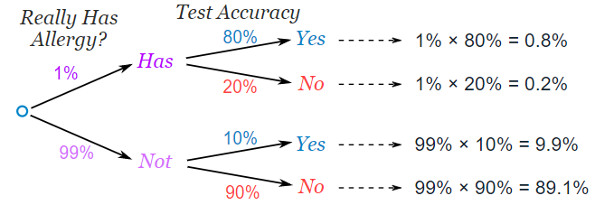

First of all, let's check that all the percentages add up:

0.8% + 0.2% + 9.9% + 89.1% = 100% (good!)

And the two "Yes" answers add up to 0.8% + 9.9% = 10.7%, but **only 0.8% are correct**.

**0.8/10.7 = 7% (same answer as above)**

1. **Bayes' Theorem**

Bayes' Theorem has a special formula for this kind of thing:

P(A|B) = P(A)P(B|A)

-------------------------------------------

P(A)P(B|A) + P(not A)P(B|not A)

where:

P means "**Probability of**"

| means "**given that**"

A in this case is "**actually has the allergy**"

B in this case is "**test says Yes**"

**P(A|B) means** "The probability that Jhon actually **has the allergy given that the test says Yes**"

**P(B|A) means** "The probability that **the test says Yes given that Jhon actually has the allergy**"

To be clearer, let's change A to has (actually has allergy) and B to Yes (test says yes):

P(has|Yes) = P(has)P(Yes|has)

------------------------------------------------------------

P(has)P(Yes|has) + P(not has)P(Yes|not has)

P(has|yes) = 0.01×0.8

------------------------------------------------------

0.01×0.8 + 0.99×0.1

= 0.0748...=Which is about 7%

**Basic Concept of Probability**

* Random variables
* Probability distributions
* Expected value

**Probability Distributions:-**

A **probability distribution** is ANY form of representation that tells us the probability for all possible values of X.

There is no such thing as a **negative probability**. Also, The total of all probabilities in a probability distribution should be equal to 1.

|  |  |
| --- | --- |
| **Economic Cycle(X)** | **Probability(P(x))** |
| Recession | 0.1 |
| Normal | 0.7 |
| Boom | 0.2 |

Now, through some calculations you creates a probability distribution with the above data:

|  |  |
| --- | --- |
| **X (Net Revenue of Project, in ₹ crores)** | **P(x)** |
| -305 | 0.1 |
| 15 | 0.7 |
| 95 | 0.2 |

**Ex 02:-**

A probability distribution table links every outcome of a statistical experiment with the probability of the event occurring.

The **outcome** of an experiment is listed as a **random variable**, usually written as a capital letter (for example, X or Y). For example, if you were **to toss a coin three times in the GAME of 8 times**, the possible outcomes are:

TTT, TTH, THT, HTT, THH, HTH, HHT, HHH

You have a 1 out of 8 chance of getting no heads at all if you throw TTT. The probability is 1/8 or 0.125, a 3/8 or 0.375 chance of throwing one head with **TTH, THT, and HTT**, a 3/8 or 0.375 chance of throwing two heads with either **THH, HTH, or HHT**, and a 1/8 or .125 chance of getting three heads.

The following table lists the random variable (the number of heads) along with the probability of you getting either 0,1,2, or 3 heads.

|  |  |
| --- | --- |
| **Number of heads (X)** | **Probability P(X)** |
| 0 | 0.125 |
| 1 | 0.375 |
| 2 | 0.375 |
| 3 | 0.125 |

**What is Expected Value?**

Expected value is exactly **what you might think it means intuitively**: the return you can expect for some kind of action.

For example, if you take a 20 question multiple-choice test with A,B,C,D as the answers, and you guess all “A”, then you can expect to get 25% right (5 out of 20). The math behind this kind of expected value is:

The probability (P) of getting a question right if you guess: .25

The number of questions on the test (n)*: 20

P x n = .25 x 20 = 5

*You might see this as X instead.

This type of expected value is called an expected value for a binomial random variable. It’s binomial because there are only two possible outcomes: you get the answer right, or you get the answer wrong.

**Basic Expected Value Formula:-**

The basic expected value formula **is the probability of an event** multiplied by the **amount of times the event happens**: (P(x) * n).

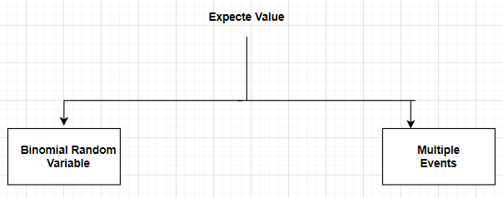

1. **Binomial Radom Variable**:- Example which are defined above are binomial random variable.

Formula for calculation is (P(x) * n).

Where n= no of trails P(x) is probability of success

Ex03:- let’s take coin is tossed 10 times and we have to find the probability of getting head so proability of **getting head in one experiment is 0.5 so 10 times is 0.5*10= 5**

1. **Multiple events:-**

EV(X)=x1∗P(X=x1)+x2∗P(X=x2)+x3∗P(X=x3)+...........+xn∗P(X=xn)

**OR**

E(X)=∑ xn∗P(X=xn)

**OR**

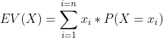

Where xn is number of trails.

Lets assume we have a bag containing Red balls and Blue balls, I have to do 100 experiment each time drawing 4 balls. So drawing 4 red balls is 0.133(13%), drawing 4 blue balls is 0.027(2.7%) and all other out come 84% in the 100 experiment. If you get 4 red balls in one experiment you will win 150 Rs. And if you get 4 blue balls you have to pay 150 rs and any other out come you will pay 10 rs.

What will be the expected value now for X (the amount of money won by a player after playing the game once)?ie means if you play this experiment once then how much prize mony you might win.

|  |  |  |
| --- | --- | --- |
| **Outcome** | **Prize** | p(x) |
| 4 red balls | 150 | 0.133 |
| 4 blue balls | -150 | 0.027 |
| Any other outcome | -10 | 0.84 |

***EV(X) = (150*0.133) + (-150*0.027) + (-10*0.840) = +7.5.***

**Let’s Answer some Questions**

European roulette contains the numbers 0 to 36 written in an irregular sequence.The players can bet on any number from 0 to 36. For example, let’s say that Kriti bets £100 on the number 5. Now, a ball would be dropped into the wheel, which is then given a spin.

If the ball lands on the pocket marked 5, Kriti would win (£100)*36 = £3,600, resulting in net winnings of £3,600 - £100 = £3,500. However, if the ball lands on any other pocket, Kriti would not win anything, resulting in net winnings of £0 - £100 = - £100.

Let’s see what the expected value is for Kriti’s net winnings if she plays this game and bets £100 on the number 5.

1. what is the probability of Kriti winning the game if she bets on the number 5?

**Solution**:- 1/37

There are a total of 37 equally likely possibilities (0 to 36). However, there is only one possibility in which Kriti will win, i.e. the one in which the ball would land on the pocket marked 5. Hence, the probability of her winning the game is 1/37.

1. we define the random variable X as Kriti’s net winnings if she plays this game and bets £100 on the number 5. What is the expected value of X?

Solution:-

*expected value of* ***X = P(X=-100)*(-100) + P(X=3500)*3500***

*(36/37)*(-100)+(1/37)*(3500) =* ***-2.70.***

*There are two possible values of X, 3,500 and -100. The probability of Kriti’s net winnings being 3,500 is basically the probability of her winning the game, which, as we saw in a previous question, is 1/37. The probability of her net winnings being equal to -100 is basically the probability of her losing the game, which is 36/37*

**What is a Probability Distribution?**

A probability distribution tells you what the probability of an event happening is. Probability distributions can show simple events, like tossing a coin or picking a card. They can also show much more complex events, like the probability of a certain drug successfully treating cancer.

There are many different types of probability distributions in statistics including:

* Basic probability distributions which can be shown on a probability distribution table.
* Binomial distributions, which have “Successes” and “Failures.”
* Normal distributions, sometimes called a Bell Curve.

The sum of all the ***probabilities in a probability distribution is always 100%*** (or 1 as a decimal).

**The Binomial Distribution**

"Bi" means "two" (like a bicycle has two wheels) ...... so this is about things with two results.

Tossing a Coin:Did we get Heads (H) or Tails (T)

We say the probability of the coin landing H is ½

And the probability of the coin landing T is ½

**Throwing a Die:**

We say the probability of a four is 1/6 (one of the six faces is a four)

And the probability of not four is 5/6 (five of the six faces are not a four)

**Note that a die has 6 sides but here we look at only two cases: "four: yes" or "four: no"**

Let's Toss a Coin!Toss a fair coin three times ... what is the chance of getting two Heads?

Tossing a coin three times **(H is for heads, T for Tails)** can get any of these 8 outcomes:

HHH coin headcoin headcoin head

HHT coin headcoin headcoin tail

HTH coin headcoin tailcoin head

HTT coin headcoin tailcoin tail

THH coin tailcoin headcoin head

THT coin tailcoin headcoin tail

TTH coin tailcoin tailcoin head

TTT coin tailcoin tailcoin tail

Which outcomes do we want?

"Two Heads" could be in any order: "HHT", "THH" and "HTH" all have two Heads (and one Tail).

So ***3 of the outcomes produce "Two Heads"***.What is the probability of each outcome?

Each outcome is equally likely, and there are 8 of them, so each outcome has a probability of 1/8

So the probability of event "Two Heads" is:

Number of

outcomes we want Probability of

each outcome

3 × 1/8 = 3/8

So the chance of getting Two Heads is 3/8

We used special words: ***Outcome***: any result of three coin tosses (8 different possibilities)

***Event***: "Two Heads" out of three coin tosses (3 outcomes have this)3 Heads, 2 Heads, 1 Head, None

The calculations are (P means "Probability of"):

P(Three Heads) = P(HHH) = 1/8

P(Two Heads) = P(HHT) + P(HTH) + P(THH) = 1/8 + 1/8 + 1/8 = 3/8

P(One Head) = P(HTT) + P(THT) + P(TTH) = 1/8 + 1/8 + 1/8 = 3/8

P(Zero Heads) = P(TTT) = 1/8

We can write this in terms of a Random Variable, X, = "The number of Heads from 3 tosses of a coin":

P(X = 3) = 1/8

P(X = 2) = 3/8

P(X = 1) = 3/8

P(X = 0) = 1/8

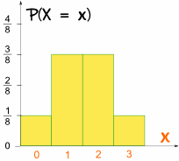

**It is symmetrical!**

**Making a Formula**

binomial probability is given by -

**P(X=r)= nCr(p)r(1−p)n-r**

**[[REFER HE HAND WRITTEN NOTES]]**

Where n is no. of trials, p is probability of success and r is no. of successes after n trials.

Total number of trials is fixed at n

Each trial is binary, i.e., has only two possible outcomes - success or failure

Probability of success is same in all trials, denoted by p

**Some questions on Binomial Distribution:-**

1. A student attempts a test with 10 multiple choice questions, where each question has 4 possible options. She does not know the correct answer to any of the questions and just randomly selects one of the 4 options for each of them. The probability that she would still get 3 questions correct is:

Solution:- **10C3(1/4)3(3/4)7*= 0.25.***

*There are a total of 4 options. Hence, the probability that the student would randomly select the correct option is 1 / 4. Hence, p = 1 / 4. Now, the probability of getting 3 out of 10 questions correct can be found by using the binomial probability for n = 10, r = 3. Hence, the probability =*10C3(1/4)3(3/4)7*= 0.25.*

Binomial distribution is applicable in situations where there are a fixed number of yes or no questions, with the probability of a yes or a no remaining the same in all the questions.

**cumulative probability:-**

cumulative probability of x, denoted by F(x), which is the probability that the random variable X **takes a value less than or equal to x**.

In mathematical terms, you would write ***cumulative probability F(x) = P(X<x)***. For example, F(4) = P(X<4), F(3) = P(X<3).

For example, we found F(2), the probability of getting 2 or fewer red balls in our game. It was calculated as:

F(2) = P(X < 2) = P(X = 0) + P(X = 1) + P(X = 2) = 0.0256 + 0.1536 + 0.3456 = 0.5248

**Some Binomial Distribution Questions**.

**Case01:**

Suppose you take **10 random pasta packets** from the market and get it tested for the amount of lead. It just so happens that you have picked out packets from a very defective batch, and there is a 5% probability that any pasta packet you select is going to be defective.

1. What is the probability that 2 of the 10 packets tested would turn out to be defective?

**Solution:-**

**P(X=r)= nCr(p)r(1−p)n-r**

**10C2(0.05)2(1-0.05)10-2** = 0.0746, or 07.46%.

Let’s define X as the number of pasta packets found to be defective after testing 10 packets.

Then, X would follow a binomial distribution with n = 10 and p = 0.05 r=2 trails.

1. What is the probability that, after testing these 10 packets, not more than 2 packets would turn out to be defective(basically cumulative probability).

If X is defined as the number of pasta packets found to be defective after testing 10 packets, then X would follow a binomial distribution with n = 10 and p = 0.05. So, the probability asked in the question becomes

**P(X<=2) = P(X=0) + P(X=1) + P(X=2)** =**10C0(0.05)0(0.95)10**+**10C1(0.05)1(0.95)9**+**10C2(0.05)2(0.95)8**

=***0.9884, or 98.84%.***

1. Let’s define X as the number of packets found to be defective after the 10 packets have been tested. What will be the expected value of X?

Solution:- **EV(X) = 0.5**

If X is defined as the number of pasta packets found to be defective after testing 10 packets, then X would follow a binomial distribution with n = 10 and p = 0.05. Now, you want to find the expected value, which would be equal to **EV(X) = 0*P(X=0) + 1*P(X=1) + 2*P(X=2) + 3*P(X=3) + 4*P(X=4) + 5*P(X=5) + 6*P(X=6) + 7*P(X=7) + 8*P(X=8) + 9*P(X=9) + 10*P(X=10)**. Using a spreadsheet to calculate the individual probabilities, you can find that the expected value EV(X) = 0.5

**Case02:-**

Suppose a new cancer treatment has been discovered, claiming to increase the one year survival rate for pancreatic cancer to 40%. In other words, the probability that a patient suffering from pancreatic cancer would survive for at least one year after receiving this treatment is 40%.

1. The hospital has a total of 10 patients suffering from pancreatic cancer. What is the probability that exactly 4 of these patients would survive the first year after receiving this treatment?

**Solu**:-

There are a total of 10 patients and the probability of surviving the first year is 40%, or 0.4 for each of them. Hence, the probability of 4 patients surviving is given by

**P(X=4)= 10C4(0.4)4(0.6)6 *= 0.251 or 25.1%.***

1. What is the probability that the number of patients that survive the first year after receiving the treatment would not be more than 2?

**Sol:-**

Let’s define X as the number of patients that will survive the first year after treatment. Now, according to the question, you have to find the probability of that number being less than or equal to 2, i.e. P(X<=2). You know that P(X<=2) = P(X=0) + P(X=1) + P(X=2) =

**10C0(0.4)0(0.6)10 +10C1(0.4)1(0.6)9 +10C2(0.4)2(0.6)8=  *0.167 or 16.7%***

# **Probability Density Function**

Continuous variables (when you are checking the probability of people coming to office under 45 mins)

can take on an infinite number of variables. For example, you could have a random variable Y that represents possible weights:

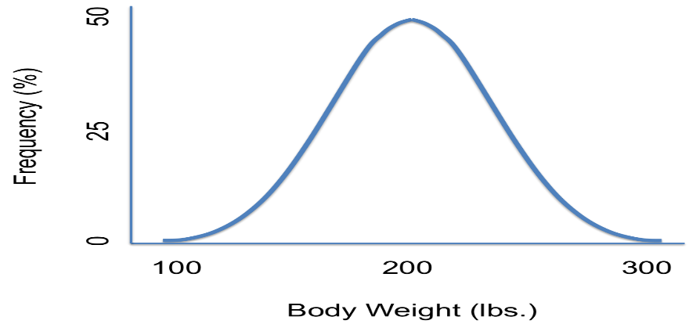

The probability density function (also called a probability distribution function) shown above shows all possible values for Y, which for this case, has an infinite amount of possibilities. For example, the random variable Y could equal **180 pounds, 151.2 pounds or 201.9999999999 pounds**.

We can use probability density functions to answer a question like:

What is the probability that a person will weigh between 150 lbs and 250 lbs?

Written in notation, the question becomes **(150 < Y < 250)**

To answer the question, shade the area on the graph:

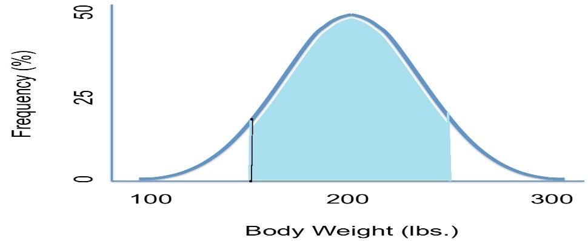

Then approximate the area. From looking at the shaded area, it looks like it’s about 75 percent.  
**So, P(150 < Y < 250) = 75%.**

You can use the same technique for figuring out the probability for less than or greater than a certain number. Just shade in the area to the right of the number (for greater than) or to the left of the number (for less than).

**What about the probability any person will weigh exactly 180lbs?** Written in notation, the question would be: P(Y=180).

* Looking at the graph, you might think that the **probability of a person weighing 180lbs is about 50%**, But that does not make sense, right?
* That half of all people weigh exactly 180lbs! What you have to think about is that someone could weigh 180 pounds or they could weigh 180 pounds and a fraction of an ounce either way. they could weigh 180.00001 pounds or they could weight 179.999999999 pounds. In fact, **the odds of someone weighing exactly 180 pounds is so tiny it’s practically zero**.
* Another way to look at this is that **if you drew the “area” for a question like this, it would just be a line. And a line has zero area!**

# **Different types of Variables**

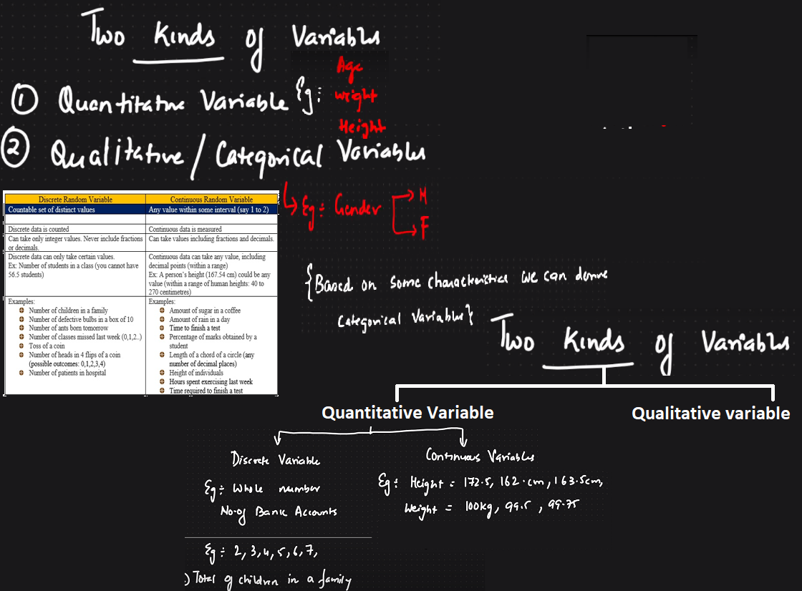

# **Variables Measurement Scale**

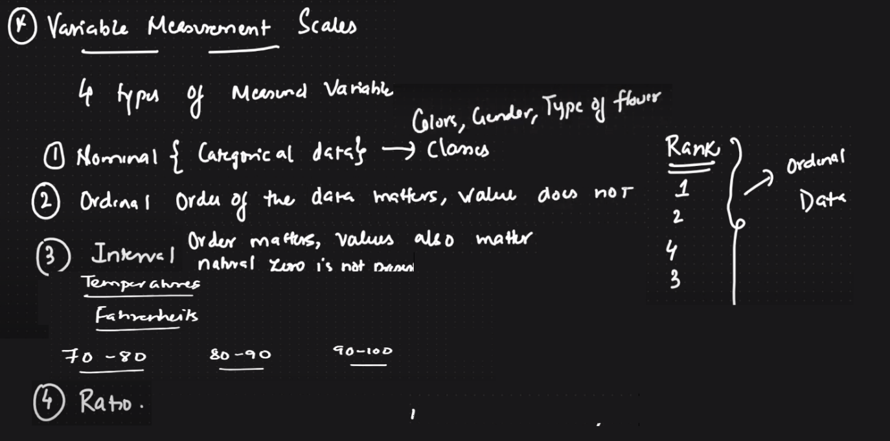

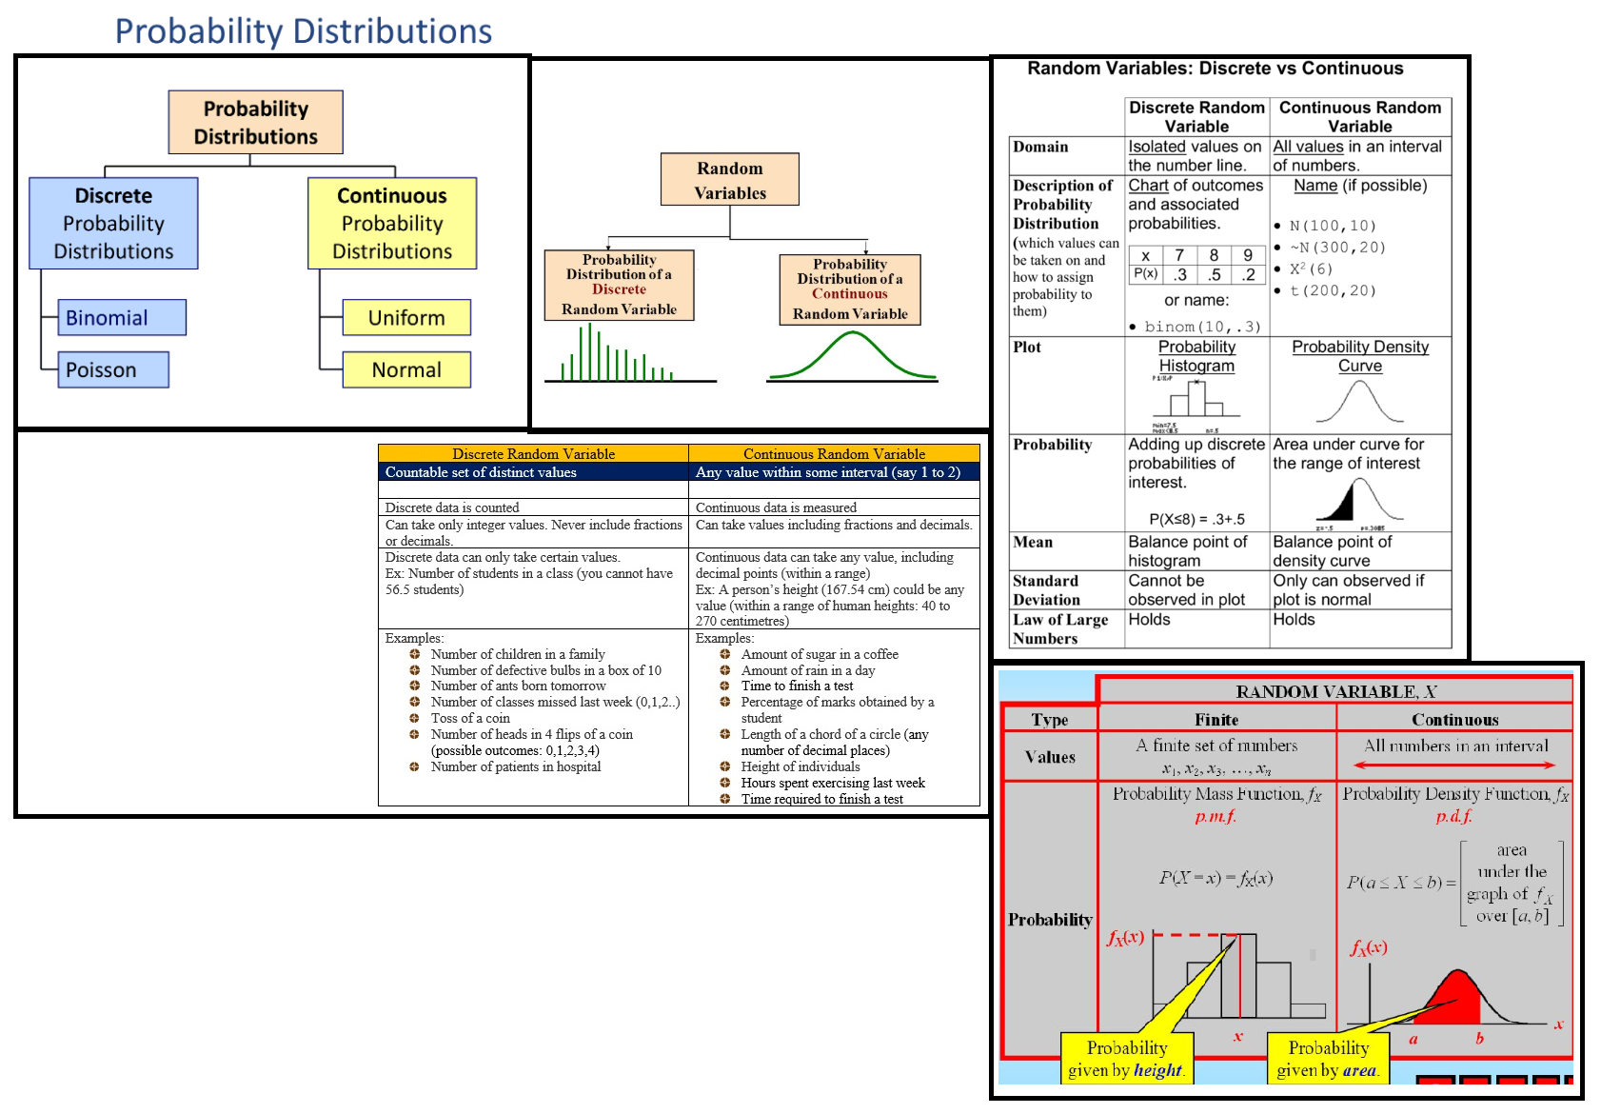

# **Cumulative distribution function vs Probability Density Function**

Cumulative distribution function, is a distribution which plots the cumulative probability of X against X.

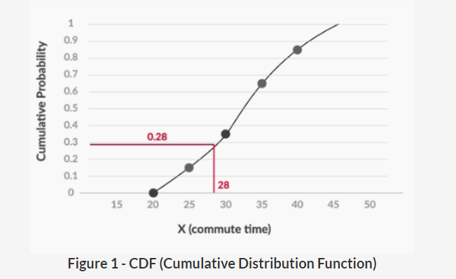

# **Probability Density Function**

A PDF, or Probability Density Function, however, is a function in which the area under the curve, gives you the cumulative probability.

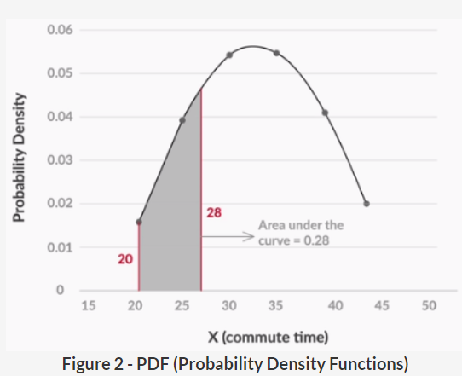

For example, the area under the curve, between 20, the smallest possible value of X and 28, gives the cumulative probability for X = 28.

The main difference between the **cumulative probability distribution** of a **continuous random** variable and a **discrete** one, is the way you plot them. While the continuous variables’ **cumulative distribution is a curve**, the distribution for discrete variables looks **more like a bar chart**:

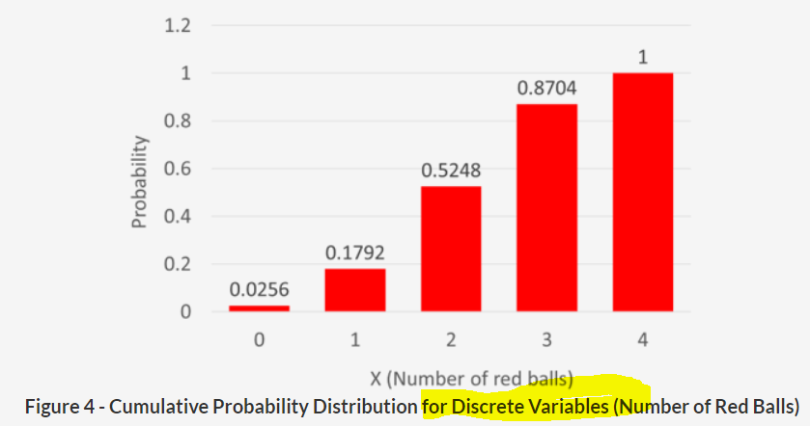

The reason for showing both so differently is that, for **discrete variables**, the cumulative probability does not change very frequently. In the discrete example, we only care about what the probability is for 0, 1, 2, 3 and 4(Means p(0) probability of getting 0 red balls and so on). This is because the cumulative probability will not change between, say, 3 and 3.999999**. For all values between these two, the cumulative probability is equal to 0.8704.**

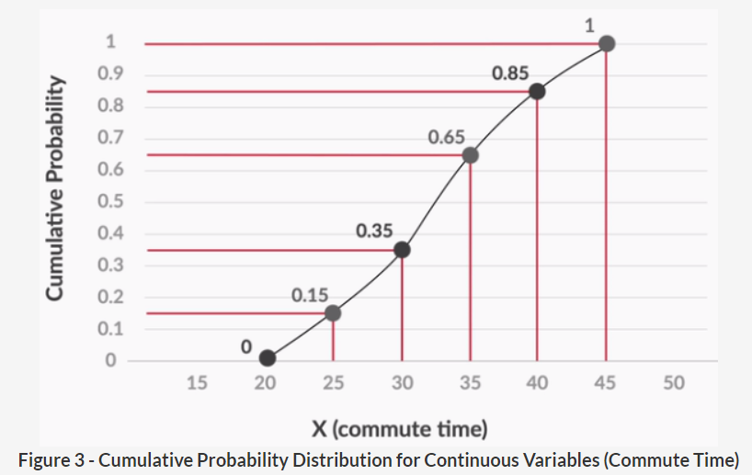

However, for the **continuous variable**, i.e. the **daily commute time**, you have a different cumulative probability value for every value of X. For example, the value of cumulative probability at 21 will be different from its value at 21.1, which will again be different from the one at 21.2 and so on(refer above image). Hence, you would show its cumulative probability as a continuous curve, not a bar chart.

**Uniform Distribution**

A commonly observed type of distribution among continuous variables is the uniform distribution.

For a **continuous random variable** following a uniform distribution, the value of probability density is equal for all possible values. Let’s explore this distribution a little more.

In a uniform PDF, all the possible values have the same probability density. The figure below shows such a uniform PDF, where the possible values are 0 to 10.

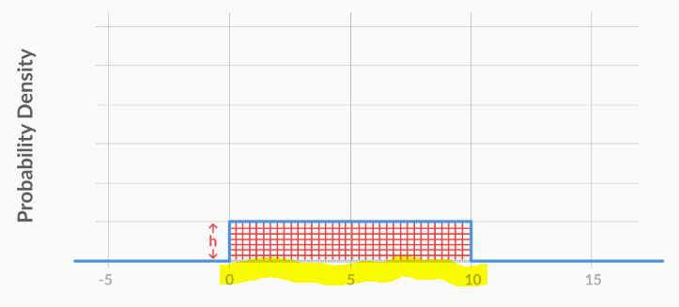

Clearly, this area is the area of a rectangle with length **10 and unknown height h**. Hence, you can say that **10*h = 1**, which gives us h = 0.1. So, the **value of the PDF for all values between 0 and 10 is 0.1**.

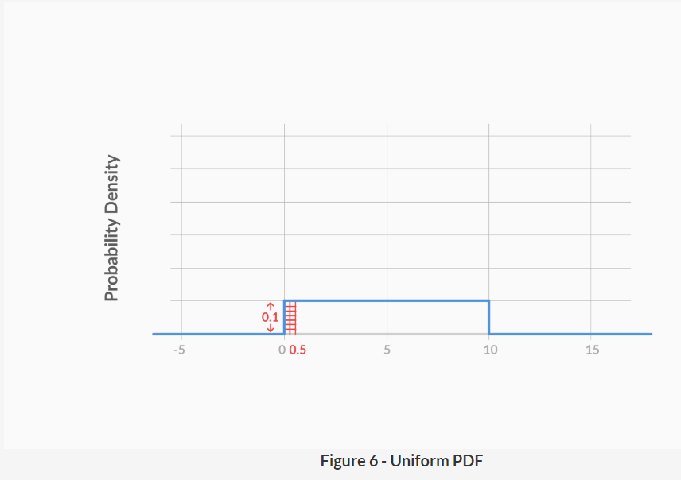

In the above figure **the cumulative probability** for **X = 0.5** is equal to the area under the curve between X = 0, the **lowest possible value, and X = 0.5**

**Area of rectangle is L*H=AREA , 0.1*0.5=0.05**

**PDFs are more commonly used in real life**. The reason is that it is much easier to see patterns in PDFs as compared to CDFs. For example, here are the PDF and the CDF of a **uniformly distributed** continuous random variable:

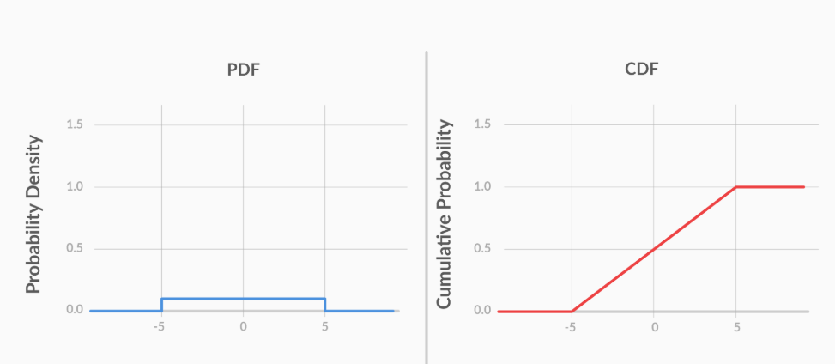

The **PDF clearly shows uniformity**, as the probability density’s value remains constant for all possible values. However, the **CDF does not show any trends** that help you identify quickly that the variable is uniformly distributed.

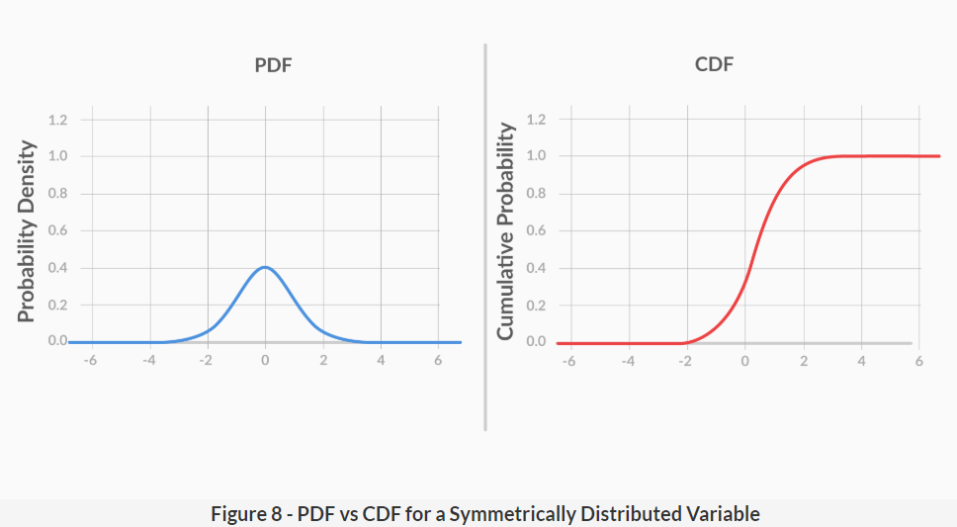

On Distributed variable Again, it is clear that the symmetrical nature of the variable is much more **apparent in the PDF than in the CDF**.Hence, generally, PDFs are used more commonly than CDFs.

Refer Krish naik vide on PDF vs CDF comparison(<https://www.youtube.com/watch?v=PYIjkw0HN1Q>)

[Please include Here you Hand written notes created after watching above video]

**Normal Distribution**

Data can be "distributed" (spread out) in different ways.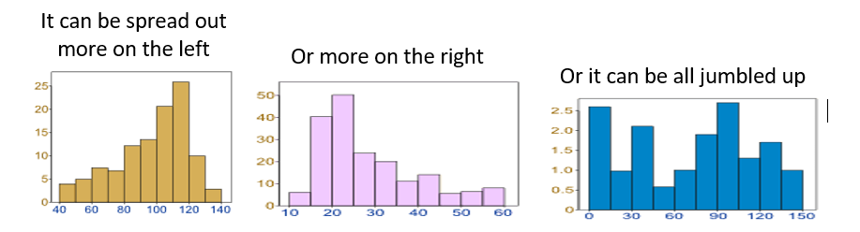

But there are many cases where the data tends to be around a central value with no bias left or right, and it gets close to a "Normal Distribution" like this:

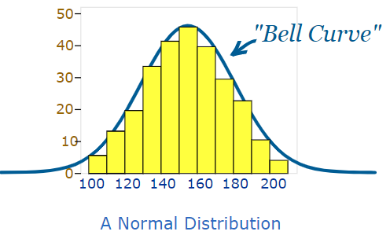

The "Bell Curve" is a Normal Distribution.And the yellow histogram shows some data that

follows it closely, but not perfectly (which is usual).It is often called a "Bell Curve"because it looks like a bell.Many things closely follow a Normal Distribution:

* heights of people
* size of things produced by machines
* errors in measurements
* blood pressure
* marks on a test

We say the data is "normally distributed":

normal distribution with mean median mode at centre

The Normal Distribution has:

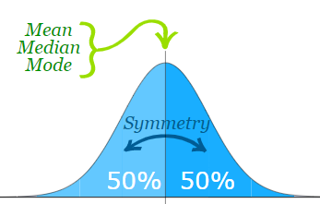 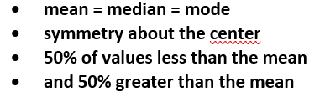

**The 1-2-3 rule**

All data that is normally distributed follows **the 1-2-3 rule**. This rule states that there is **a 68% probability** of the variable lying within 1 standard deviation of the **mean 95% probability** of the variable lying within 2 standard deviations of the **mean 99.7% probability of the variable lying within 3 standard deviations of the mean.**

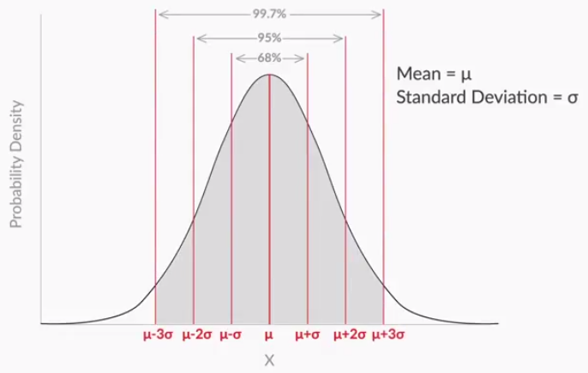

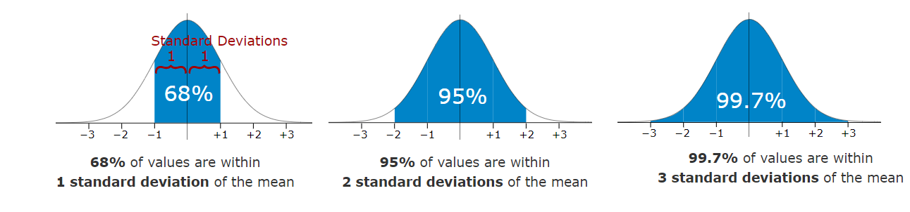

The heights of a group of adult men would be normally distributed. we asked 50 male employees for their height and then plotted the probability density function using that data.

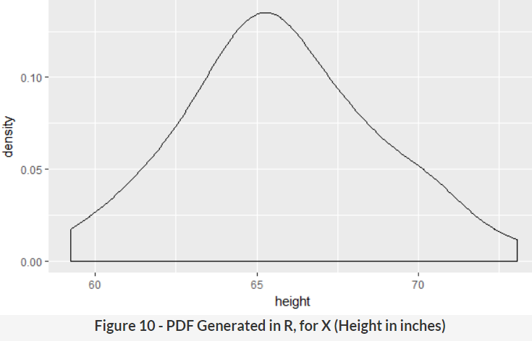

**Example**: 95% of students at school are **between 1.1m** and **1.7m** tall.

Assuming this **data is normally distributed** can you calculate the mean and standard deviation?

The mean is **halfway between** 1.1m and 1.7m:**Mean = (1.1m + 1.7m) / 2 = 1.4m**

**95% is 2 standard deviations** either side of the mean (a total of 4 standard deviations) so:

1 standard deviation= (1.7m-1.1m) / 4 = 0.6m / 4 = **0.15m** And this is the result:

μ+ σ, μ- σ 🡪 68%

μ+ 2σ, μ-2σ 🡪 95%

μ+ 3σ, μ- 3σ 🡪 97%

**0.15m** is called **"Standard Score", "sigma" or "z-score".**

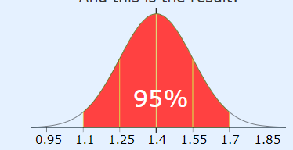

It is good to know the standard deviation, because we can say that any value is:

* likely to be **within 1 standard** deviation (68 out of 100 should be)
* very likely to be **within 2 standard** deviations (95 out of 100 should be)
* almost certainly **within 3 standard** deviations (997 out of 1000 should be)

Example: In that same school one of your friends is 1.85m tall .You can see on the bell curve that **1.85m** is 3 standard deviations from the mean of 1.4, so:

Your friend's height has a **"z-score" of 3.0.**It is also possible to calculate **how many standard deviations** **1.85** is from the mean.

How far is 1.85 from the mean?

It is 1.85 - 1.4 = **0.45m** from the mean,How many standard deviations is that? The standard deviation is 0.15m, so:**0.45m / 0.15m = 3 standard deviations(This is called ZSCORE).**

**Z=(X−μ)/σ == (1.85-1.4)/0.15**



So to convert a value to a **Standard Score ("z-score")**:

first subtract the mean,then divide by the Standard Deviation **And doing that is called "Standardizing**":

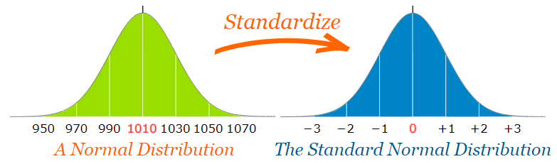

Zscore are nothing but the value which is represent with the standard deviation.From the below **1,2,3 are called zscore.**

μ+ **1**σ, μ- **1**σ

μ+ **2**σ, μ-**2**σ

μ+ **3**σ, μ- **3**σ

**Standard Deviation**

The Standard Deviation is a measure of how spread out numbers are.The symbol for Standard Deviation is **σ (the Greek letter sigma).**

This is the formula for Standard Deviation:-

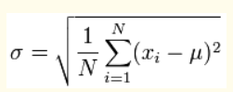

Say we have a bunch of numbers like **9, 2, 5, 4, 12, 7, 8, 11**.

To calculate the standard deviation of those numbers:

1. Work out the Mean (the simple average of the numbers)

2. Then for each number: subtract the Mean and square the result

3. Then work out the mean of those squared differences.

4. Take the square root of that and we are done!

**Ex:-**

Example: 9, 2, 5, 4, 12, 7, 8, 11, 9, 3, 7, 4, 12, 5, 4, 10, 9, 6, 9, 4

The mean is: μ (the greek letter "mu")

(9+2+5+4+12+7+8+11+9+3+7+4+12+5+4+10+9+6+9+4)/20 = 140/20 = 7 = **μ = 7**

Then for each number: subtract the Mean and square the result This is the part of the formula that says:

**(xi - μ)^2**

So what is xi ? They are the individual x values 9, 2, 5, 4, 12, 7, etc...

(9 - 7)^2 = (2) ^2 = 4, (2 - 7)^2 = (-5) ^2 = 25, (5 - 7) ^2 = (-2) ^2 = 4 , (4 - 7) ^2= (-3) ^2 = 9 ,

(12 - 7) ^2= (5) ^2 = 25 , (7 - 7) ^2 = (0) ^2 = 0 ,(8 - 7) ^2 = (1) ^2 = 1

**4, 25, 4, 9, 25, 0, 1, 16, 4, 16, 0, 9, 25, 4, 9, 9, 4, 1, 4, 9**

Then work out the mean of those squared differences. To work out the mean, add up all the values then divide by how many. First add up all the values from the previous step using **"Sigma": Σ**

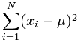

Which means: Sum all values from **(x1-7)2 to (xN-7)2**

We already calculated (x1-7)^2=4 etc. in the previous step, so just sum them up:

= 4+25+4+9+25+0+1+16+4+16+0+9+25+4+9+9+4+1+4+9 = **178**

But that isn't the mean yet, we need to divide by how many, which is done by multiplying by 1/N (the same as dividing by N):

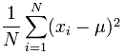

Mean of squared differences = (1/20) × 178 = 8.9 **(Note: this value is called the "Variance")**

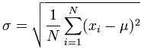

σ = √(8.9) = **2.983**

**Sample Standard Deviation:-**

Example: Sam has **20 rose bushes**, but only counted the flowers on 6 of them. The "population" is all 20 rose bushes,and the "sample" is the 6 bushes that Sam counted the flowers of.Let us say Sam's flower counts are: **9, 2, 5, 4, 12, 7**

We can still estimate the Standard Deviation But when we use the sample as an estimate of the whole population, the Standard Deviation formula changes to this:

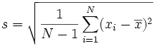

Note:- observe that in calculating the sample standard deviation we use **1/(N-1)**

The important change is "N-1" instead of "N" (which is called "**Bessel's correction**").The symbols also change to reflect that we are working on a sample instead of the whole population:

* **The mean is now x̄** (for sample mean) **instead of μ** (the population mean),
* **And the answer is s** (for Sample Standard Deviation) instead of σ.
* But that does not affect the calculations. Only N-1 instead of N changes the calculations.

Using sampled values 9, 2, 5, 4, 12, 7

The mean is (9+2+5+4+12+7) / 6 = **39/6** = 6.5 **x̄ = 6.5**

Then for each number: subtract the Mean and square the result:

(9 - 6.5)^2 = (2.5)^2 = **6.25,**(2 - 6.5) ^2 = (-4.5) ^2 = **20.25**

(5 - 6.5) ^2 = (-1.5) ^2 = **2.25,**(4 - 6.5) ^2 = (-2.5) ^2 = **6.25**

(12 - 6.5) ^2 = (5.5) ^2 = **30.25,**(7 - 6.5) ^2 = (0.5) ^2 = **0.25**

Since we are calculating the Sample Standard Deviation, so instead of dividing by how many (N), we will divide by N-1.

Sum = 6.25 + 20.25 + 2.25 + 6.25 + 30.25 + 0.25 = **65.5**

**Divide by N-1: (1/6-1) × 65.5 = 13.1** (This value is called the "**Sample Variance**")



s = √(13.1) = **3.619...**Comparing previous example **whole population** we got: **Mean = 7, Standard Deviation = 2.983**...

When we used the **sample**, we got: **Sample Mean = 6.5**, **Sample Standard Deviation = 3.619...**

Our **Sample Mean was wrong by 7%**, and our Sample **Standard Deviation was wrong by 21%.**

Sample error is formula is =

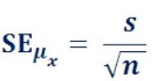

Why Take a Sample? Mostly because it is easier and cheaper.Imagine you want to know what the whole country thinks ... you can't ask millions of people, so instead you ask maybe 1,000 people.

**"You don't have to eat the whole animal to know that the meat is tough."**

This is the essential idea of sampling. To find out information about the population (such as mean and standard deviation), we do not need to look at all members of the population; we only need a sample.

But when we take a sample, we lose some accuracy.

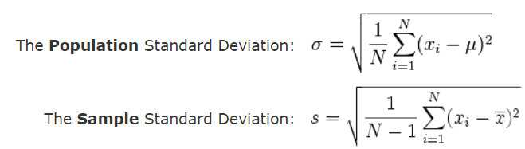

# **Sample Techniques**

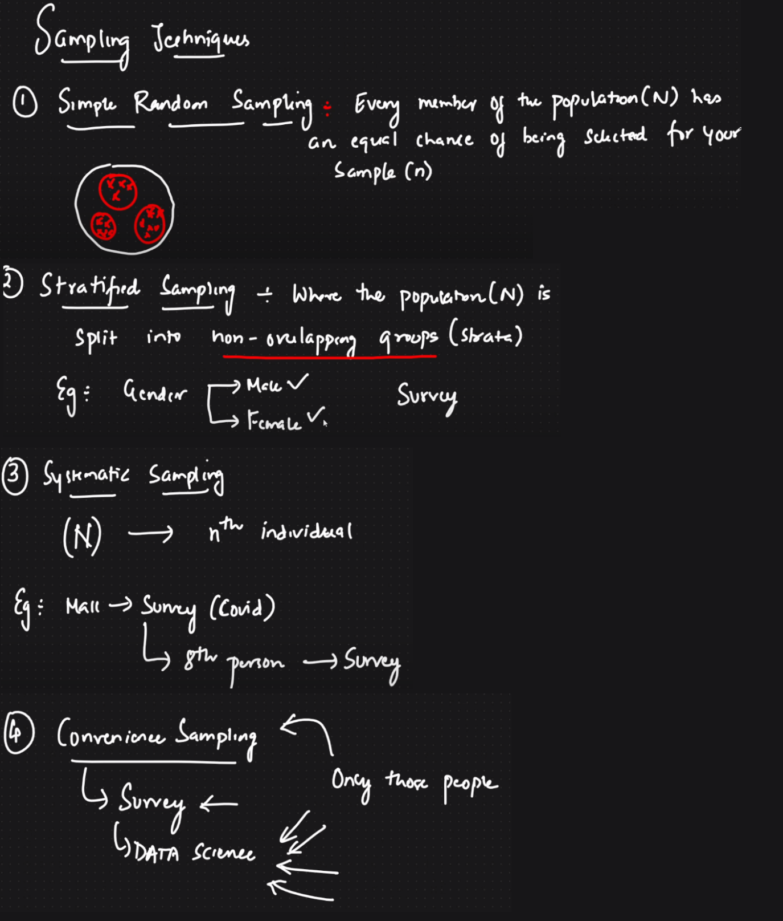

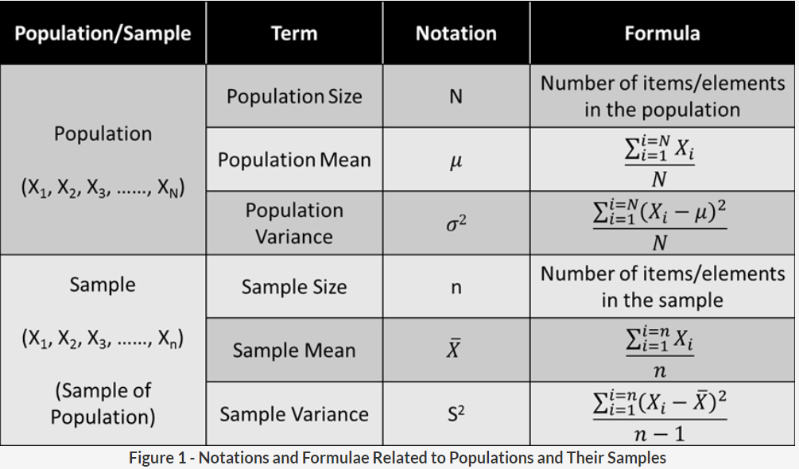

**Ex:-**For an upcoming government project, you want to find the average height of the students in Class VIII of a given school. Instead of asking each student, **suppose you took a few students** as your **sample** and wrote the data down:

|  |  |
| --- | --- |
| Roll Number | Height |
| 8012 | 121.92 cm |
| 8045 | 133.21 cm |
| 8053 | 141.34 cm |
| 8099 | 126.23 cm |
| 8125 | 175.74 cm |

**Solution: -**

In this sample, we have data of 5 students. Hence, the sample size is equal to 5.**n=5**

Mean of sample data is (121.92+133.21+141.34+126.23+175.74) /5 =698.44/5= **139.688** = **x̄ = 139.688**

standard deviation (S)=

Then for each number: subtract the Mean and square the result:

(121.92-**139.688**)^2 + (133.21- **139.688**) ^2 + (141.34- **139.688**) ^2+(126.23- **139.688**) ^2 (175.74- **139.688**) ^2 = **1841.25988**

Since we are calculating the Sample Standard Deviation, so instead of dividing by how many (N), we will divide by N-1.

Sum = 1841.25988

**Divide by N-1: (1/5-1) ×1841.25988 =460.315** (This value is called the "**Sample Variance**")



**s = √(460.315) = 21.45**

**ZSCORE**

 Zscore is the probability of how far the value of X is from µ — specifically, what **multiple of σ** is the **difference between X and µ**.

**Z=(X−μ)/σ**

* z is the "z-score" (Standard Score)
* x is the value to be standardized
* μ ('mu") is the mean
* σ ("sigma") is the standard deviation

**Ex:-**

A survey of daily travel time had these results (in minutes):

26, 33, 65, 28, 34, 55, 25, 44, 50, 36, 26, 37, 43, 62, 35, 38, 45, 32, 28, 34

The Mean is **38.8 minutes**, and the **Standard Deviation is 11.4 minutes** (you can refer the above calculation to see how the SD is calculated).**Convert the values to z-scores ("standard scores")**.

To find **ZScore**  for 26 mins : first subtract the mean: 26 − 38.8 = −12.8 (Mean is **38.8**),

then divide by the Standard Deviation: −12.8/11.4 = **−1.12**

So 26 is **−1.12* Standard Deviations(**μ-**1.12**\*σ) from the Mean(μ🡪 Mean σ 🡪 standard deviation)

**μ🡪 38.8**

**σ 🡪11.4**

Here are the first three conversions to find **Z Score**

Original Value Calculation Standard Score(z-score)

26 (26-**38.8**) / 11.4 = −1.12

33 (33-**38.8**) / 11.4 = −0.51

65 (65-**38.8**) / 11.4 = +2.30

... ... ...

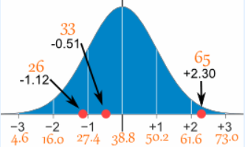

Here are the first three conversions using the "z-score formula": **z =(x – μ)/σ**

* μ = 38.8
* σ = 11.4

|  |  |  |
| --- | --- | --- |
| **x** | **(x – μ)/σ** | **z (z-score)** |
| 26 | (26 − 38.8)/11.4 | = −1.12 |
| 33 | (33 − 38.8)/11.4 | = −0.51 |
| 65 | (65 − 38.8)/11.4 | = +2.30 |
| ... | ... | ... |

**Why Standardize ...?**

**Example**: Professor Willoughby is marking a test.Here are the student's results (out of 60 points):

20, 15, 26, 32, 18, 28, 35, 14, 26, 22, 17

Most students didn't even get 30 out of 60, and **most will fail**.The test must have been really hard, so the Prof decides to **Standardize** all the scores and **only fail people 1 standard deviation below the mean**.

The **Mean is 23(μ)**, and the **Standard Deviation** is **6.6(σ)**, and these are the Standard Scores(**Z scores**):

-0.45, -1.21, 0.45, 1.36, -0.76, 0.76, 1.82, -1.36, 0.45, -0.15, -0.91

**Now only 2 students will fail (the ones lower than −1 standard deviation).**

Below is the "bell-shaped" curve of the **Standard Normal Distribution**. It is a Normal Distribution with mean 0 and standard deviation 1(**The 1-2-3 rule**).

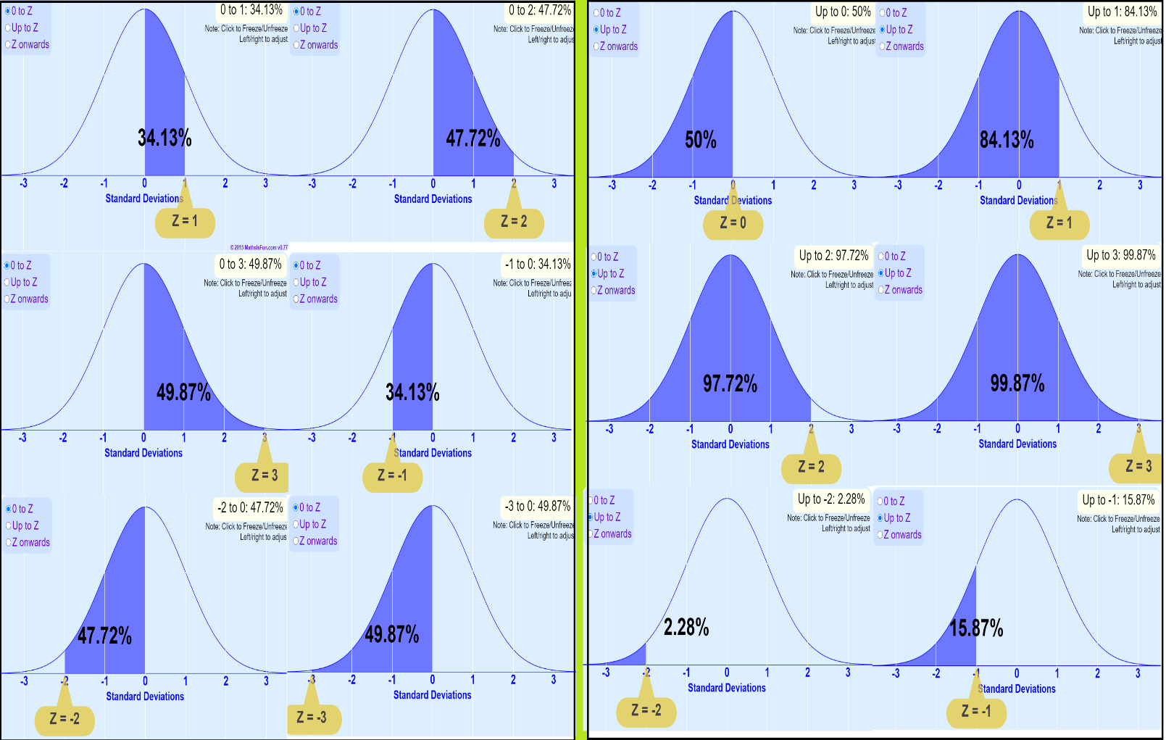

**Example**: Percent of Population Z Between -1 and 2.From −1 to 0 is the same as from 0 to +1:

At the row for 1.0, first column 1.00, there is the value **0.3413,**From 0 to +2 is:

At the row for 2.0, first column 2.00, there is the value **0.4772**

Add the two to get the total between -1 and 2:

0.3413 + 0.4772 = 0.8185 And **0.8185 is 81.85%** So 81.85% of the population are between -1 and +2 Standard Deviations from the Mean.

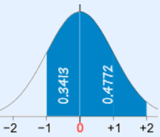

Z Table tells you how many standard deviations away from the mean your random variable is. As you just saw, you can find the cumulative probability corresponding to a given value of Z, using the Z table (basically it starts from **(μ- 3σ) left most on the normal distribution**)

Below graph helps us to understand the calculation of Zscore(cumulative probability). In the first graph z=-2 when you check this against Zscore table you see the corresponding value as **0.0228** which is **2.28%** as you can see in the graph.

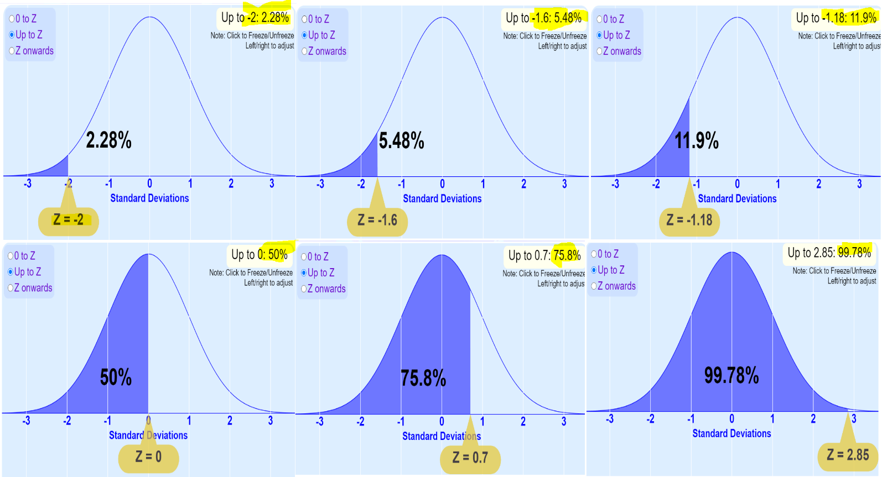

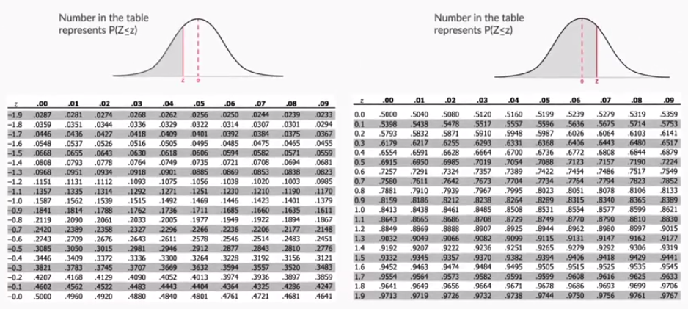

Alternatively, you can use the following equation to find the cumulative probability(**BETTER USE ZTABLE**): **F(Z)=1√2π∫Z−∞e−t22dt**

Here is the Standard Normal Distribution with percentages for every half of a standard deviation, and cumulative percentages:

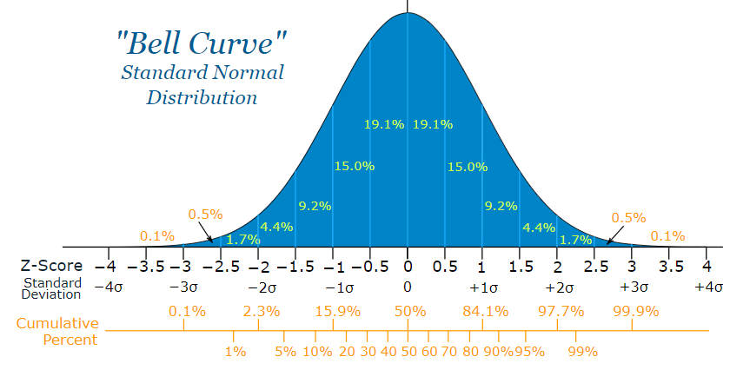

**Example**: Your score in a recent test was 0.5 standard deviations above the average, how many people scored lower than you did?

* Between 0 and 0.5 is 19.1%
* Less than 0 is 50% (left half of the curve)
* So the total less than you is: 50% + 19.1% = **69.1%**

In theory 69.1% scored less than you did.

**A Practical Example**: Your company packages sugar in 1 kg bags.When you weigh a sample of bags you get these results:

**1007g, 1032g, 1002g, 983g, 1004g, ... (a hundred measurements)**

Mean = 1010g,Standard Deviation = 20g

The normal distribution of your measurements looks like this:

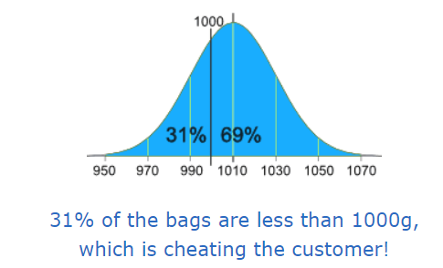

Let's adjust the machine so that 1000g is: **at −3 standard deviations**:

From the big bell curve above we see that 0.1% are less. But maybe that is too small(Basically by reducing standard deviation we are trying to reduce people who have got cheated) at −2.5 standard deviations:

Below 3 is 0.1% and between 3 and 2.5 standard deviations is 0.5%, together that is 0.1% + 0.5% = 0.6% (a good choice I think)

So let us adjust the machine to have **1000g** at **−2.5 standard deviations** from the mean.Now, we can adjust it to:

increase the amount of sugar in each bag (**which changes the mean**), or make it more accurate (which reduces the standard deviation)

**Let us try both.**

Adjust the mean amount in each bag:-The standard deviation is 20g, and we need 2.5 of them:

**2.5 × 20g = 50g** So the machine should average **1050g**, like this so that average becomes 1000g if the store owner packs each sugar back with extra 50 g.

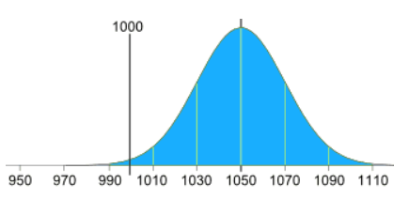

**Adjust the accuracy of the machine**

Or we can keep the same mean (of 1010g), but then we need 2.5 standard deviations to be equal to 10g:

10g / 2.5 = 4g

So the standard deviation should be 4g, like this:(We hope the machine is that accurate!)

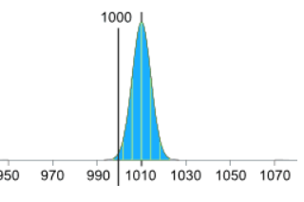

A low value of **σ(Standard deviation)** means that the graph is **narrow**, while a high value implies that the graph is wider. This will happen because the wider graph will clearly have more values away from the mean, resulting in a **high standard deviation**.

**Example:-**

What is the probability of a normally distributed random variable lying within 1.65 standard deviations of the mean?

**Sol**:- **90%**

You have to find the probability of the variable lying between μ-1.65σ and μ+1.65σ. i.e. P(μ-1.65σ < X < μ+1.65σ). In terms of Z, this becomes P(-1.65 < Z < +1.65). This would be equal to

P(1.65) - P(-1.65) = 0.95 - 0.05 = **0.90**. =**90%**

**Some Important concepts:-**

* For a continuous random variable, the probability of getting an exact value is very low, **almost zero.**
* Hence, when talking about the probability of continuous random variables, you can only talk in terms of intervals. For example, for a particular company, the probability of an employee’s **commute time being exactly equal to 35 minutes was zero**, but the probability of an employee having a commute time between **35 and 40 minutes was 0.2**.
* Hence, for continuous random variables, **probability density functions** (**PDFs**) and **cumulative distribution functions** (**CDFs**) are used, instead of the bar chart type of distribution used for the probability of discrete random variables. These functions are preferred because they talk about **probability in terms of intervals**.
* Between a PDF and a CDF is that in a CDF, you can find the **cumulative probability directly by checking the value at x**. However, for a PDF, you need to **find the area under the curve** between the lowest value and x to find the cumulative probability.

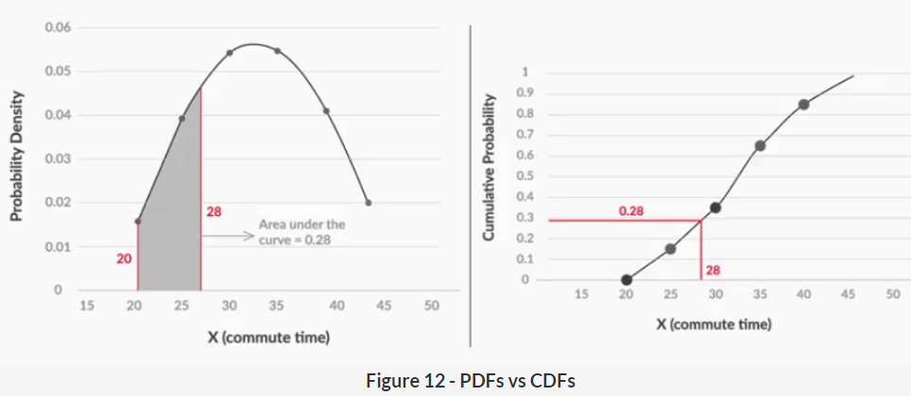

**Ex:-**

The regulatory authority selects a random tablet from Batch Z2. Based on previous knowledge, you know that Batch Z2 has a **mean paracetamol level of 510 mg**, and its **standard deviation is 20 mg**.

What is the probability that the tablet that has been selected by the authority has a paracetamol level **below 550 mg**?

Solution:- **98%**

Let’s define X as the amount of paracetamol in the selected tablet. Now, X is a normally distributed random variable, with mean μ = 510 mg and standard deviation σ = 20 mg.

Now, you have to find the probability of X being less than 550, i.e. P(X<550). **Converting this to Z**, you get P(X<550) = **P(Z<{550-510}/20)** =2(**checking it in the Z table**)= P(Z<2) = 0.977, or 97.7%.

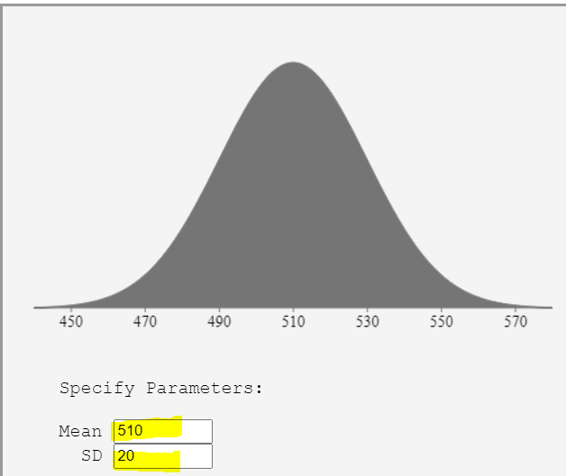

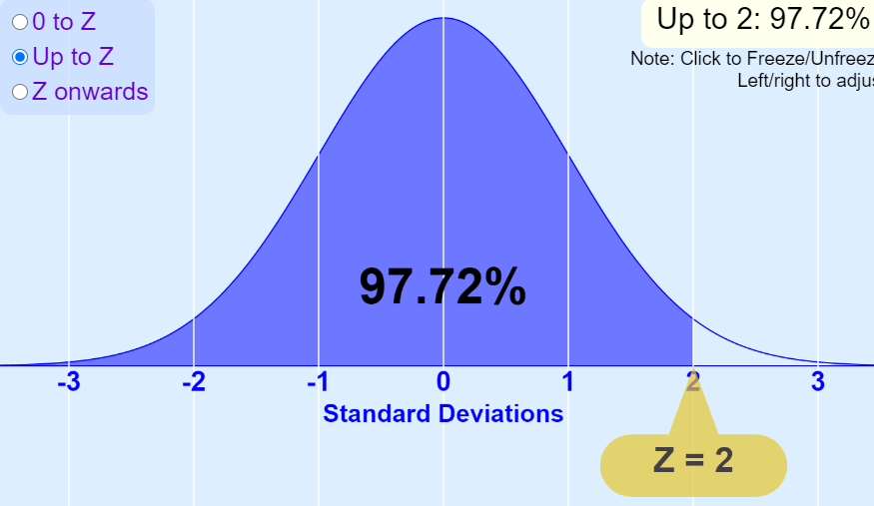

**Ex02:-**

Now, the company’s QC (Quality Control) department comes and selects a tablet at random from Batch Z2. It is interested in finding if the paracetamol level is above 450 mg or not.What is the probability that the tablet selected by QC has a **paracetamol level above 450 mg**?

Solution:-

Let’s define X as the amount of paracetamol in the selected tablet. Now, X is a normally distributed random variable, with **mean μ = 510 mg** and standard deviation **σ = 20 mg**.

Now, you have to find the probability of X being more than 450, i.e. **P(X>450)**. Converting this to Z, you get **P(X>450) = P(Z>{450-510}/20) =-3(refer the Zscore table)= P(Z>-3) = 1 - P(Z<-3) = 0.9987, or 99.87%.**



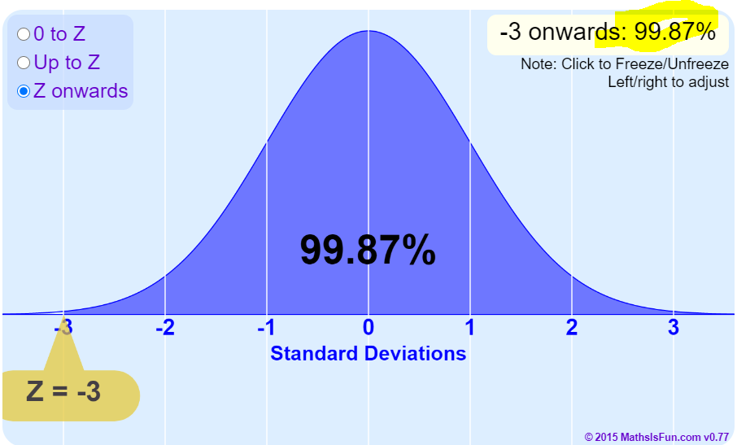

**Ex03:-**

Now, let’s say that QC decides to sample one more tablet. This time, it selects a tablet from Batch Y4. Based on previous knowledge, you know that Batch Y4 has a **mean paracetamol level of 505 mg**, and its **standard deviation is 25 mg**. This time, QC wants to check both the upper limit and the lower limit for the paracetamol level.

What is the probability that the tablet selected by QC has a paracetamol level **between 450 mg and 550 mg?**

**Solution:-**

Let’s define X as the amount of paracetamol in the selected tablet. Now, X is a normally distributed random variable, with mean μ = 505 mg and standard deviation σ = 25 mg.

Now, you have to find the probability of X being more than 450 and less than 550, i.e. P(450 < X < 550). Converting this to Z, you get P(450 < X < 550) = P({450-505}/25 < Z < {550-505}/25) = P(-2.2 < Z < 1.8) = P(Z < 1.8) - P(Z < -2.2) = **0.9641 - 0.0139 = 0.9502, or 95%.**

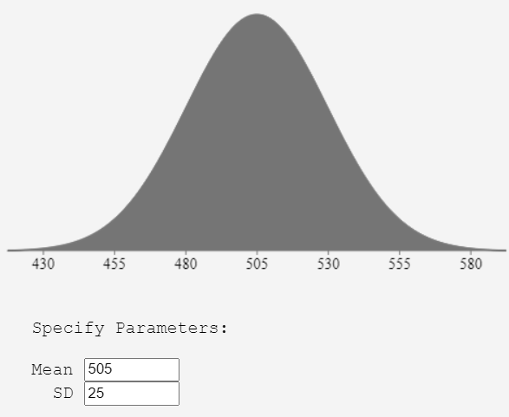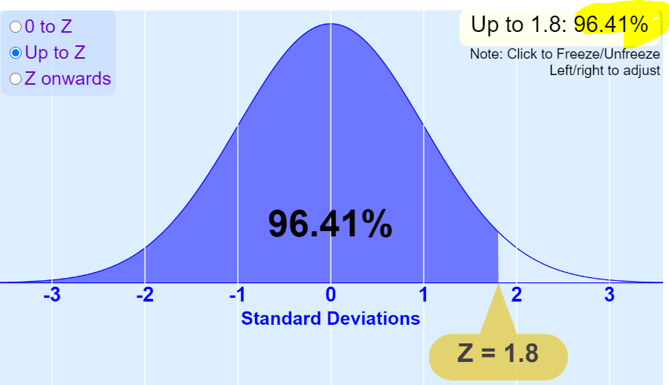

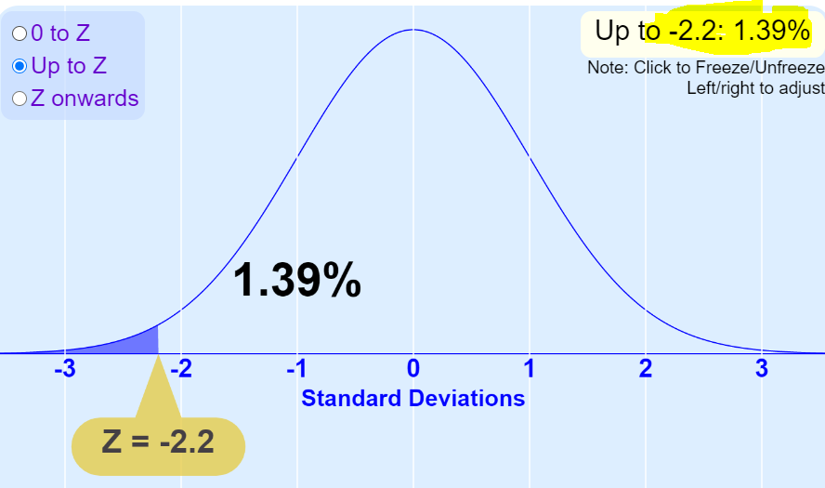

**Ex04:-**

The graph you see above represents the PDF of a uniformly distributed random variable X. As you can see, the probability density is equal for all the possible values of X (-5 to +5).

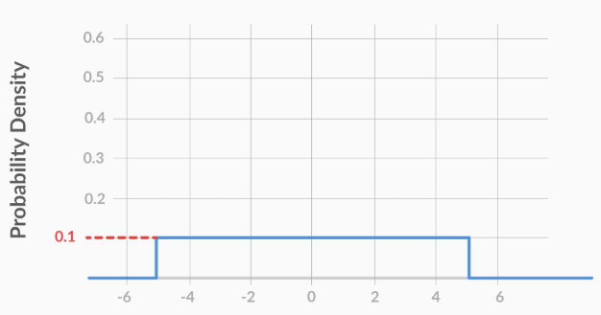

What is the probability of the random variable **X** lying between **-1.5 and +2.5,** i.e. **P(-1.5<X<2.5)**?

**Sol:-**

The probability of the variable lying between -1.5 and 2.5 would be equal to the area under the PDF, between X = -1.5 and X = 2.5.

This would be equal to the area of a rectangle, with breadth 0.1 and length 2.5 - (-1.5) = 4. Multiplying the two, you get the area of the rectangle, which is equal to 0.1*4 = 0.4.

Area of rectangle is =l*b = 0.1*4= 0.4

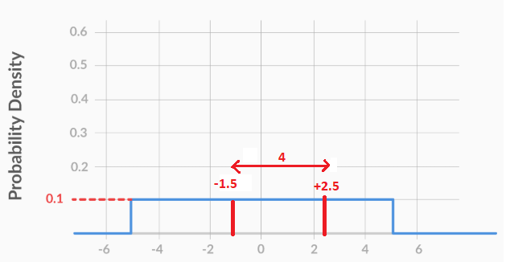

**Example:-** It was found that an astronomer trying to estimate the distance between Earth and Uranus always makes an error. This error is normally distributed, with **µ = 0 km and σ = 1,000 km.**

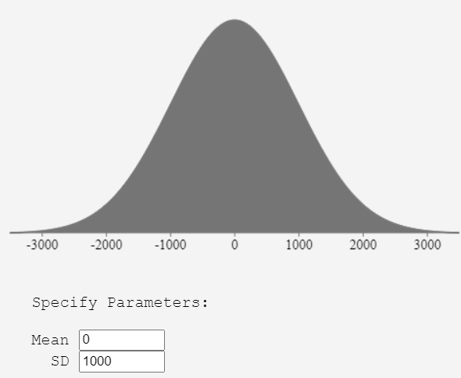

Hence, what is the probability that the astronomer under- or over-estimates the distance by less than 500 km?

**Solution:**

Let’s define X as the astronomical error, which is normally distributed with mean 0 km and standard deviation 1,000 km.

Now, you have to find the probability that -**500 < X < 500**, i.e. **P(-500 < X < 500)**.

**P(X>500) = P(Z>{500-0}/1000) =0.5(check the value in ztable to get the cumulative probability)**

**P(X<500) = P(Z<{0-500}/1000) =-0.5(check the value in ztable to get the cumulative probability)**

Converting this to Z, it becomes P(-0.5 < Z < 0.5) = **P(Z < 0.5) - P(Z < -0.5)** = 0.6915 - 0.3085 = 0.3830, or **38.30%.**

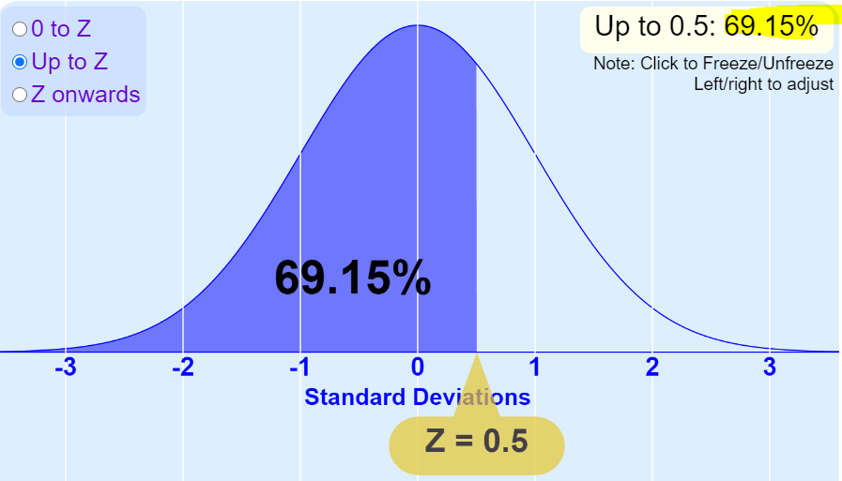

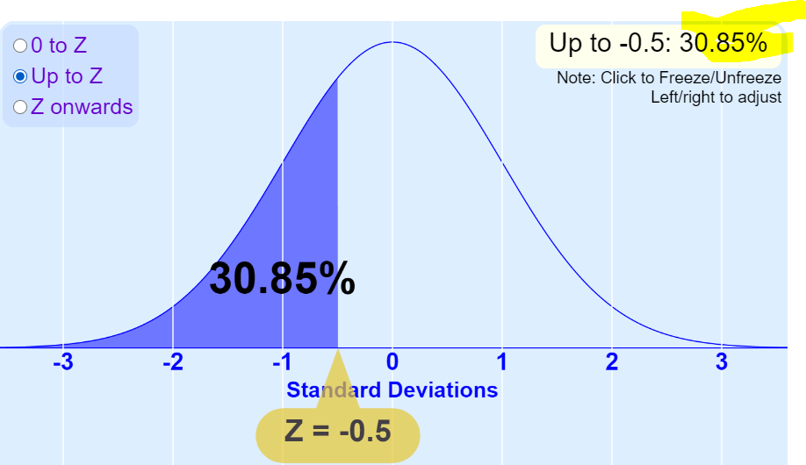

**Sample Distribution Mean: -**

The sampling distribution’s mean is denoted by **μ¯X** , as it is the **mean of the sampling means**. Let’s see what it is for this sampling distribution.

|  |  |
| --- | --- |
| Sample No. | Sample Mean **x̄** |
| 1 | 3.2 |
| 2 | 2.6 |
| 3 | 2.8 |
| 4 | 2 |
| 5 | 3 |
| 6 | 2.8 |
| 7 | 2.8 |
| 8 | 2 |
| 9 | 2.6 |
| 10 | 2.6 |

The sampling distribution’s mean would be equal to the sum of all the sample means, divided by 10.

=26.4/10 =**2.64**

**μ¯X=2.64**



Using the mean from the previous question, you can find the standard deviation using the formula.

Note that you would divide by **n** and not **n-1** as you have the data for **all 10 entries** of the distribution, and you don't need to sample the distribution.

Now, using the formula, you get that the value of the standard deviation of the distribution is **0.3666**.

**σ=0.3666**

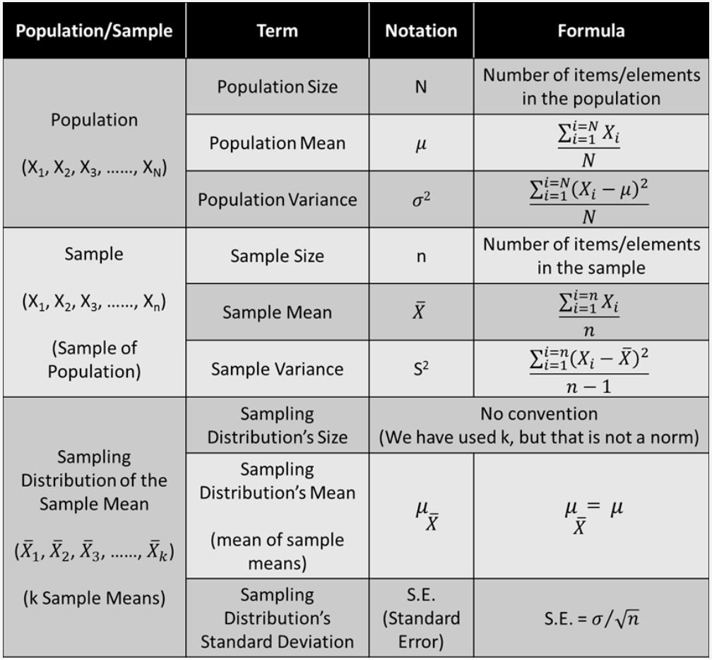

There are two important properties for a sampling distribution of the mean:

* Sampling distribution’s mean (**μ¯X**) = Population mean (μ)
* Sampling distribution’s standard deviation (**Standard error**) = σ/(√n)

, where **σ is the population’s standard deviation and n is the sample size**

**Central Limit Theorem**

If we collect 30 measurements and calculate the **mean**, and then do that a bunch of times (collect 30 measurements and calculate a **mean**), a histogram of those means will be a **normal distribution**.

This suggests that an **individual mean, calculated from 30 measurements**, is, in and of itself, normally distributed. For example, if we had a uniform distribution and we collected 30 values from it and calculated the mean, then that mean would be normally distributed.

**The central limit theorem says that, for any kind of data, provided a high number of samples has been taken, the following properties hold true:**

* Sampling distribution’s mean (μ¯X  ) = Population mean (μ)
* Sampling distribution’s standard deviation (Standard error) = **σ/(√n)**
* For n > 30, the sampling distribution becomes a normal distribution

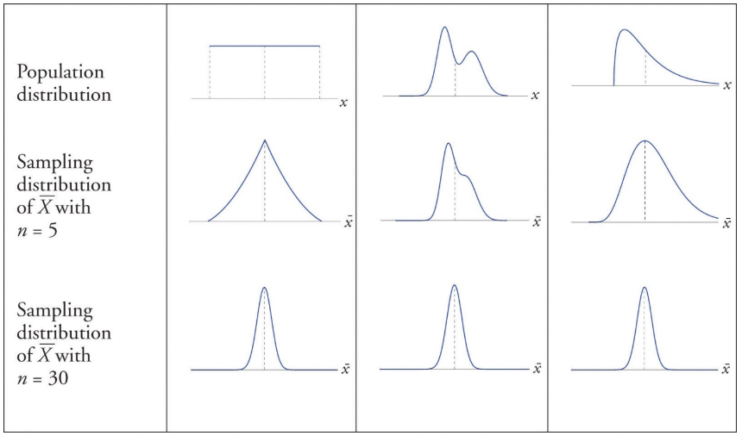

Above picture, shows **3 different population distributions which are not normal**. Sampling distribution of means gets a little closer to normal distribution when we take n =5 and almost normal distribution

**when n=30.**

***Why CLT is important?***

The field of statistics is based on fact that it is highly impossible to collect the data of entire population. Instead of doing that we can gather a subset of data from a population and use the statistics of that sample to draw conclusions about the population.

In practice, the unexpected appearance of normal distribution from a population distribution is skewed (even heavily skewed). Many practices in **statistics such as hypothesis testing** make this assumption that the population on which they work is normally distributed.

This assumption basically simplifies matters and we overcome the problem of the data belonging to the population which is not normal. Thus, even we don’t know the shape our distribution where our data comes from but according to Central Limit Theorem we can treat sampling distribution of any population as normal. The conclusions of the Central Limit Theorem to hold we need sample size to be large enough(at least 30).

**Understanding CLT with an example:-**

Consider that there are 15 sections in the science department of a university and each section hosts around 100 students. Our **task is to calculate the average weight of students in the science department**.

**Solution:-**

First, measure the weights of all the students in the science department **Add all the weights, Finally**, divide the total sum of weights with a total number of students **to get the average,**But what if the size of the data is **humongous**? Does this approach make sense? **Not really** – measuring the weight of all the **students will be a very tiresome and long process**. So, what can we do instead? Let’s look at an alternate approach.

**First, draw groups of students at random from the class. We will call this a sample. We’ll draw multiple samples, each consisting of 30 students.**

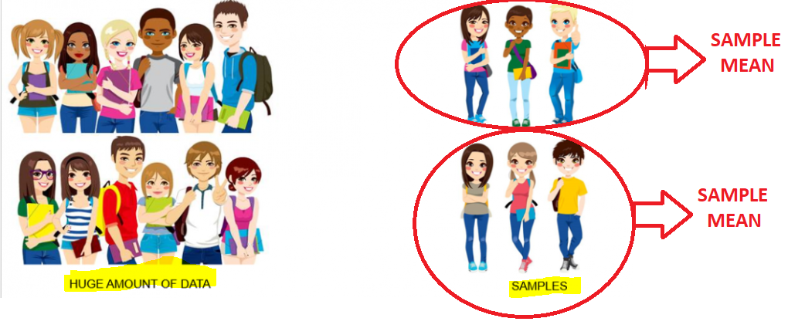

Calculate the individual mean of these samples, Calculate the mean of these sample means.This value will give us the approximate mean weight of the students in the **science department.**

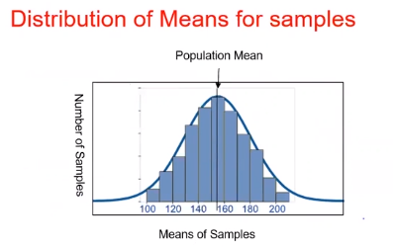

Additionally, the histogram of the **sample mean weights of students** will resemble a bell curve (or normal distribution).This, in a nutshell, is what the **central limit theorem** is all about.

**Assumptions Behind the Central Limit Theorem**

* The data must follow the randomization condition. It must be sampled randomly.
* Samples should be independent of each other. One sample should not influence the other samples
* Sample size should be not more than 10% of the population when sampling is done without replacement
* The sample size should be sufficiently large. Well, it depends on the population. When the population is skewed or asymmetric, the sample size should be large. If the population is symmetric, then we can draw small samples as well
* In general, a sample size of 30 is considered sufficient when the population is **symmetric**.

**Some more Important points on CLT**

* Instead of finding the **mean** and **standard deviation** for the **entire population**, it is beneficial to find the mean and standard deviation for only a **small representative sample**. You may have to do this because of **time** and/or **money** constraints.
* For example, for an office of **30,000 employees**, we wanted to find the average commute time. So, instead of asking all employees, we **asked only 100 of them and collected the data**. The mean = 36.6 minutes and the standard deviation = 10 minutes.
* However, it would not be fair to infer that the population mean is exactly equal to the sample mean. This is because the flaws of the sampling process must have led to some error. Hence, the **sample mean’s value has to be reported with some margin of error**.

For example, the mean commute time for the office of **30,000 employees** would be equal to **36.6** **+ 3 minutes**, 36.6 + 1 minutes, or 36.6 + 10 minutes, i.e. **36.6 minutes + some margin of error**.

* The **sampling distribution**, which is basically the distribution of sample means of a population, has some interesting properties which are collectively called the central limit theorem, which states that **no matter how the original population is distributed**, the sampling distribution will follow these three properties:

1. Sampling distribution’s mean (μ¯X  ) = Population mean (μ)
2. Sampling distribution’s standard deviation (Standard error) = **σ/(√n)**

where  is the population’s standard deviation and n is the sample size

1. For n > 30, the sampling distribution becomes a normal distribution

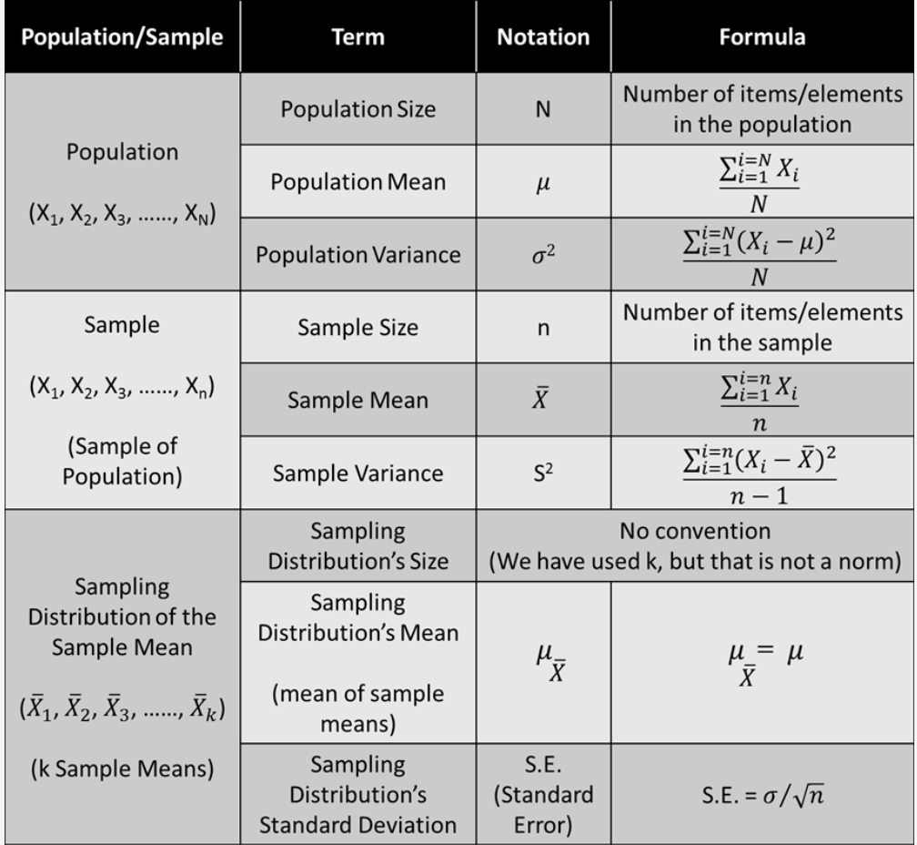

**Understanding central limit theorem with example:-**

Let’s say that you work for a news agency, which is conducting an exit poll for the MCD (Municipal Corporation of Delhi) elections.

You have been **tasked with predicting the winner for ward 75N** (Ashok Vihar). You asked **100 randomly selected voters from this ward** to name the party they had voted for.

|  |  |
| --- | --- |
| Contesting Party | Number of Voters |
| **BJP** | 58 |
| **INC** | 42 |

From this sample, you have to estimate the percentage of voters that might have voted for BJP.

So, you define **X as the proportion of people that voted for BJP**. Then, the frequency distribution for X would be:

|  |  |
| --- | --- |
| **X** | **Frequency** |
| **1** | 58 |
| **0** | 42 |

Now, you have to find the mean for X, which is equal to (0+0+0+...... 42 times) + (1+1+1+......... 58 times), divided by the **total frequency, i.e. 100**. So, the

**mean** = 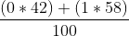 = 0.58 or **58%.**

Also, you would have to find the standard deviation for this sample of 100 voters. **Since the mean is 0.58**, the

sample’s variance= 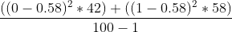 = **0.2461**.

So, the standard deviation is equal to its square root, i.e**. 0.496 or 49.6%.**

1. Now, let’s say you define Y as the proportion of people that voted for the INC party. Clearly, the mean of Y will be 0.42. What would be the standard deviation of Y?

**Solution:-**

There would be 42 people for whom Y would be equal to 1, and 58 people for whom Y would be equal to 0. Hence, the sample’s variance = (**(1−0.42)2 * 42+(0−0.42)2 * 58)/(100−1)=0.2461***. So, the standard deviation is equal to its square root, i.e. 0.496 or 49.6%*

1. Let’s say you actually took some more samples, each of size 100, and made a sampling distribution for X, the proportion of people that voted for BJP.

The mean of this sampling distribution is μ¯X = 0.50 and the standard error = 0.052.

So, for the whole survey population, i.e. all the voters in ward 75N, the proportion of people that voted for BJP is approximately equal to:

**Solution:-**

You have to find the mean for all the people or, in other words, the population mean. Using CLT, you can say that the **mean of the sampling distribution = the population mean**.

As the question says that the **sampling distribution’s mean = 0.5, the population mean also = 0.5 or 50%**

1. Similarly, let’s say you made a sampling distribution for Y, the proportion of people that voted for INC.The mean of this sampling distribution is **μ¯X = 0.50** and the **standard error is equal to 0.048**.

Now, for the whole survey population, i.e. all the voters in ward 75N, the standard deviation of Y is equal to

**Solution:-**

You have to find the standard deviation for all people or, in other words, the population standard deviation σ. Using CLT, you can say that **(σ/√n) = SE**. Hence, **(σ/√100) = 0.048,** which gives σ = .48 or 48%

**(σ/√100) = 0.048**

**σ=√100 * 0.048 =0.48= 48%**

Based on the CLT formula Sampling distribution’s standard deviation (Standard error) = **σ/(√n)**

where **is the population’s standard deviation** and n is the sample size

**CONFIDENCE INTERVALS:-**

• As the sample mean does not truly represent the population mean,we can use confidence intervals to indicate the likely range where the true mean might lie.

• Confidence intervals can be determined with different levels of certainty (e.g. 95%, 90%, 50%,…)

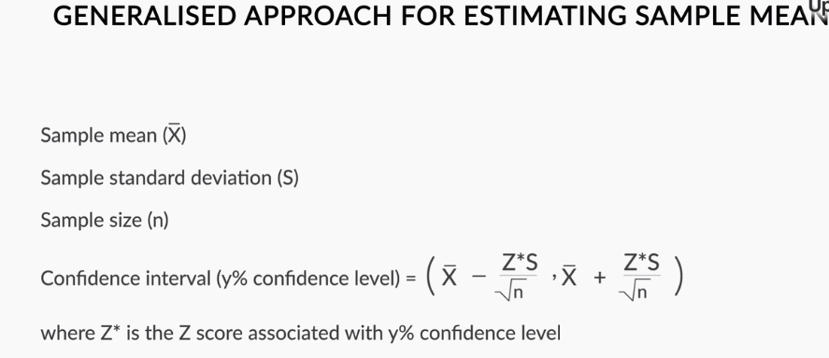

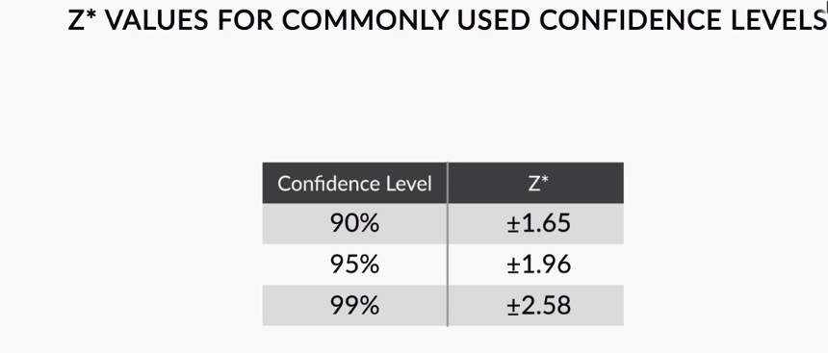

let’s say you have a sample with sample size n, mean and standard deviation S. Now, the y% confidence interval (i.e. the confidence interval corresponding to y% confidence level) for would be given by the range:

Confidence interval = 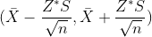

where, Z* is the Z-score associated with a y% confidence level. In other words, the population mean and sample mean differ by a margin of error given by

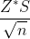.

**Some important points**

At this point, it is important to address a very common **misconception. Sampling distributions are just a theoretical exercise** and you’re not actually expected to make one in real life. If you want to estimate the population mean, **you will just take a sample**. You will **not create an entire sampling distribution**.

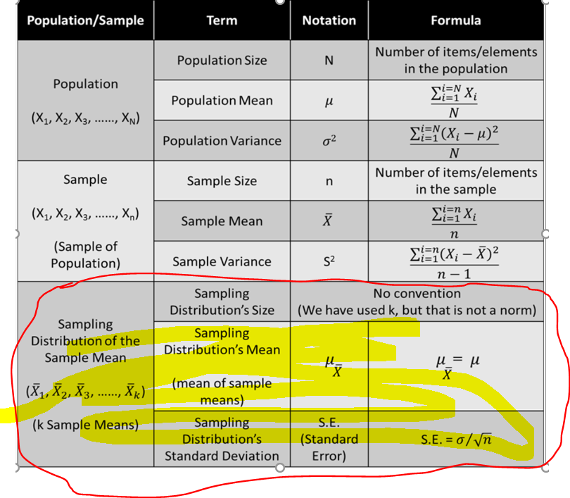

You must be wondering — if this the case, then **why did you study sampling distributions**? To understand the reason for this, let's go through the actual process of sampling. Recall that you are doing sampling **because you want to find the population mean**, albeit in the form of an interval. The three steps to follow are as follows:

* First, take a sample of size n
* Then, find the mean (μ¯X ) and **standard deviation S of this sample**
* Now, you can say that for y% confidence level, the confidence interval for the population mean μ is :-

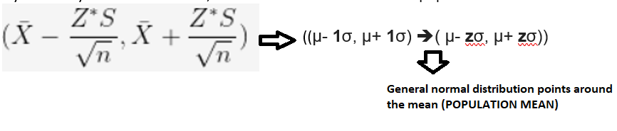

However, as you may have seen, you cannot finish step 3 without CLT. CLT lets you assume that the sample mean would be normally distributed, with mean  and standard deviation  ** (**approx.****) ,Using this assumption, it becomes possible to find many things such as **margin of error, confidence interval, etc.**

Let’s see an example of how you can use confidence intervals to make a decision. Let’s take Facebook example where FB is trying it new feature (A and B) .Let’s find the 90% confidence interval (confidence interval for 90% confidence level) for that case.

Recall that **50.5% of the 10,000 people surveyed preferred feature B** over feature A. So, if X = **the proportion of people that prefer feature B over feature A**, then, for this sample, **x̄** = 0.505 (50.5%) and n = 10,000. In addition to this, you now know the sample’s standard deviation S = 0.2(20%).

Now, you know that the actual population mean  lies between **x̄** + or - margin of error. However, now, it's vital for us to find this margin of error.

If this margin of error is, say, 1%, then that would mean that the population mean ****, which is the proportion of people that prefer feature B over feature A, lies between the range (50.5-1)% to (50.5+1)%, i.e. 49.5 % to 51.5%.

It would mean that you cannot say with certainty that  would be more than 50%. So, even though the proportion of people that prefer feature B over feature A is more than 50% in our sample, you would not be able to say with certainty that this proportion would be more than 50% for the entire population.

On the other hand, if the margin of error is, say, 0.3%, then you would be able to say that the population mean lies within (50.5-0.3)% and (50.5+0.3)%, i.e. 50.2% to 50.8%. So, you would be able to say with certainty that the proportion of people that prefer feature B over feature A is more than 50% in our sample and for the entire population too.

Now, the margin of error corresponding to 90% confidence level would be given by (Z*S)/sqrt(n) = 0.0033 (0.33%), and the population mean lies between 50.17% and 50.83%.Hence, you can say that feature B should replace feature A with 90% confidence

